Area of Study 4 – Set Works 9 and 10

World Music

Area of Study 4 – Set Works 9

‘Yiri’ Performed by Koko

Content coverage | Learning outcomes
Koko: ‘Yiri’ (AoS 4)  Listen to the performance of ‘Yiri’ by Koko.  Relevant musical vocabulary including: ostinato, improvisation, cross-rhythm, polyrhythm, syncopation, master drummer, balaphones, mbira, vocables, djembe, donno, dundun and oral tradition. | - To explore the use of rhythmic motifs and ostinati.  - To learn the set work through performing it.  - To develop improvising skills through the exploration of rhythmic elements.

Sub-Saharan African Music
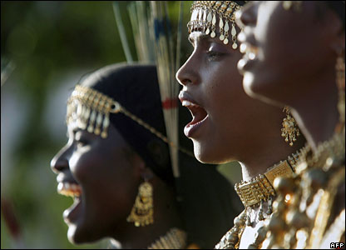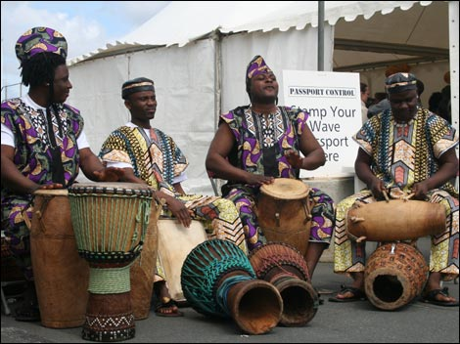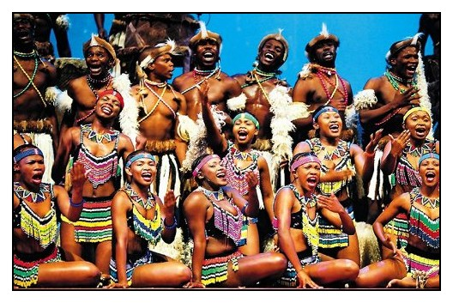
The music of sub-Saharan Africa is extremely rich, colourful and diverse. This covers a region of fifty different nations, each with its own musical traditions and languages.
The music plays an important role in African society and is used to communicate many different feelings and emotions.
Music is nearly always part of any social gathering, be it to celebrate the harvest, a birthday, wedding, funeral or even a gathering of chiefs.
On all these occasions, the music is often combined with speech and dance as well as vibrant costumes to produce exciting and dramatic performances.
The music is frequently linked to movement, which is regarded as an important made of communication - as important as the music itself. The dancers dress in vividly coloured costumes replete with body painting and elaborate masks. Stories may also be related through body actions and mime.
African music falls broadly into three strands:
- drumming
- choral song (tribal music)
- instrumental music

 | Summary of Key Features and Facts of African Music
1 | - part of everyday activities; everyone joins in clapping, singing and dancing to the music  - part of rites and ceremonies where it is performed by specialist master drummers and professional musicians known as griots.  - not normally written down but is passed down over the generations in each griot family by word of mouth (oral tradition).
2 | It came over to America with the African slaves and combined with the folk music of the European settlers to produce new styles of music such as blues, gospel and jazz. These went on to form the basis of pop music today.
3 | The music is based on repetition – rhythms, harmonies and melodies are often repeated continually to form ostinatos.
4 | Improvisation -The process in which music is made up spontaneously, without the use of written musical notation.
5 | Call and Response - Simple form involving a solo (call) followed by a group answering phrase (response).
6 | Layered textures (polyphony)
7 | Rhythm patterns interlock and overlap to form polyrhythmic patterns and exciting cross-rhythms
8 | Singing often includes glissandos (slides which are sometimes known as portamento) and slurs, whistles, yodels and swoops, use of vowel sounds such as ‘eh’, ‘ah’ and ‘oh’ (vocables).
Homework
http://www.youtube.com/watch?v=MoStKUBUi8I (Talaembé, Balafon Spectacle Series, DKD 2008 – uploaded by reggross)
Describe the difference between the role of the players at the start, and how it changes after 2 minutes

Describe the use of rhythm and metre

Why do you think the tonality and scale sounds a bit ambiguous and unusual to our ears?

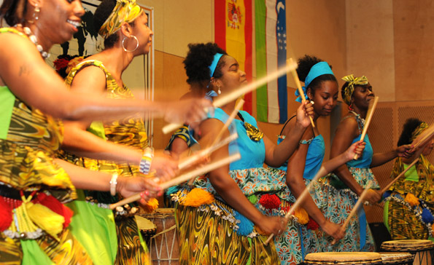
African Drumming
In African music, the drum is considered to be the most important of all the instruments. The drum has religious significance and is used in all forms of ceremonies, including weddings, funerals and the celebrations of the annual harvest. Within Africa there are hundreds of drums in African music and their names vary from region to region, and even from one tribe to the next. The most common drum is called the djembe. This is a single-head instrument shaped like a goblet and is made in a range of sizes to produce different pitches. As well as the single-headed drums, there are double-headed drums that can be played using sticks and will produce two different pitches - for example, the dundun. One of the other famous types of drum of West Africa - the donno - is known as the talking drum. This is held under the arm and played with the hand.
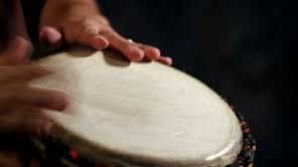
Playing techniques.
- playing hands on the skin of the drum - different sounds are made when the fingers are open or closed
- playing hands on the wooden edge of the drum
- using sticks to create a sharp staccato sound '
- Stretching the drum membrane to produce a range of pitches, particularly on the donno.

Typical Performance
- African music is founded on the oral tradition and therefore has no musical notation.
- The master drummer stands in the centre of the ensemble and is responsible for directing the whole performance.
- He will be surrounded by other drummers and percussion instruments.
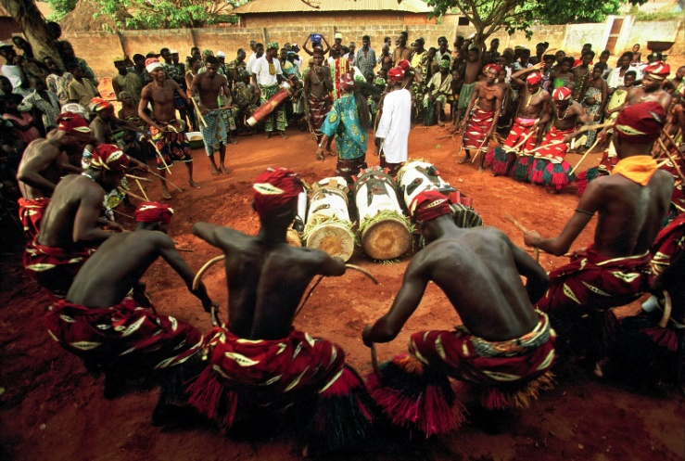
- The master drummer will signal to the other players when he is ready to start, often with a vocal cry followed by a short rhythmic solo to set the mood and tempo of the music
- This is called a cue and the other players will then come in together to play the response.
- The response could be an exact copy or even a different rhythm entirely.
- Cueing will happen throughout the music, creating a structure of contrasted sections, including solo sections
- A steady continuous beat, called the timeline, is often played by the master drummer and there may also be a percussion rattle or bells, the most common being the agogo bells.
- The complex rhythms played by the drummers create polyrhythms often with stresses that conflict with each other and with the steady constant beat of the timeline - creating cross-rhythms.
- The result is a polyrhythmic texture.
- The music will usually increase in tension the piece progresses, and the tempo and dynamics will vary from section to section to provide interest and variety in the music.

African Choral Singing
- Sub-Saharan musical traditions are centred around singing.
- Many Africans believe that music serves as a link to the spirit world.
- Singing is a vital part of everyday life and is heard at religious ceremonies, rituals and celebrations.
- Singing unites whole tribal communities and everyone takes a part, regardless of ability.
- The songs provide a means of communication.
- African languages are tone languages - that is, the pitch level (high or low) determines the actual meaning of the words.
- Therefore, the melodies and rhythms can be made to fit in pitch outlines to match the meanings and speech rhythms of the words of the song.
The common features of African songs are as follows:
- the basic form of the songs is call and response where one singer sings a line and the whole group then makes a vocal reply
- melodies are usually short and simple and repeated over and over, and usually in a scale of only four, five, six or seven different tones
- these melodies can be changed at will by other singers, so that what we end up with is a theme and then variations on that theme
- performers often improvise new melodies while the other singers continue the original melody, and it is common to have different melodies sounding simultaneously resulting in polyphonic textures
- the music can often be sung in rounds - for example, in Zulu choral music, individual voices enter at different points in a continuous cycle, overlapping in a complex and ever-changing musical texture
- harmony, which will vary from tribe to tribe. In some communities, the voices sing only in unison or parallel octaves, with the odd fourth or fifth.
- However, other groups will freely harmonise in thirds or fourths and can even sing in two or three different parts.
Koko: ‘Yiri’
Koko is a group of six musicians led by the singer and balafon player Madou Kone. ‘Yiri’ is taken from their album Burkina Faso – Balafons et tambours d’Afrique” and contains just a few sleeve notes;

When we discovered Koko, we were struck by the sheer wealth of music they produce. This group occupies a very special position in the widely renowned cultural heritage of Burkina Faso. Koko draws its inspiration from the subtle mixture of living cultures that are to be found in that part of Africa. The group is led by Madou Kone, who plays the balafon and is also an exceptional singer. The themes of Koko's songs evoke some of man's greatest battles, including the fight for survival and protection of the environment, but also creation, celebration and friendship, and attachment to the earth.
The musicians in the group Koko are:
- Madou Kone: vocals, balaphone, flute
- Sydou Traore.- vocals, balaphone
- Jacouba Kone: djembe
- Francois Naba: vocals, tam-tam, dundun, maracas
- Keresse Sanou: talking drum
- Tidiane Hema: vocals, maracas

Burkina Faso is a landlocked nation in West Africa.

Burkina Faso
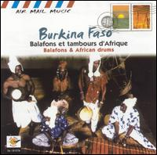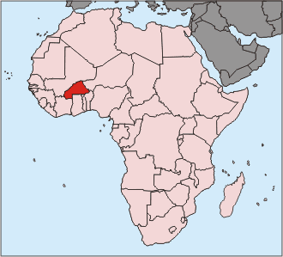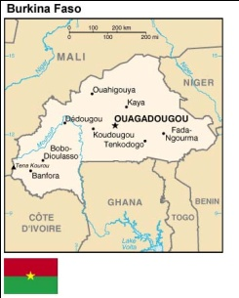

- Burkino translates as: “Men of Integrity” and Faso means: “Father’s house”
- The piece focuses on:
  - Fight for survival
  - Looking after the environment
  - Creation
  - Community celebrations
  - Friendships

INSTRUMENTATION
Instrumental the piece has 3 clear strands, tuned percussion, drums and vocals.
The following instruments are used Yiri (which means wood):
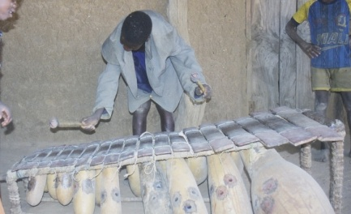
The Balafon – similar to a xylophone, gourds hang beneath the notes to make the sound resonate. The one used in Yiri uses a hexatonic (six note) scale.
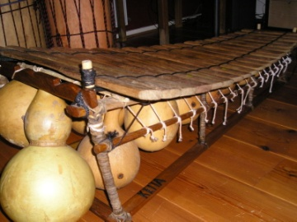

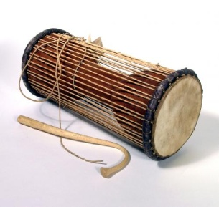
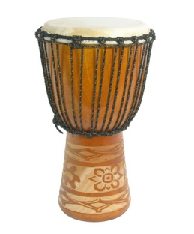
The djembe a goblet shaped drum:

The talking drum: a drum that is played with a hooked stick and can be used to imitate speech by creating different pitches and slides.

These instruments are also from Africa but are not in this piece.
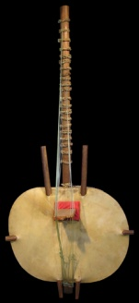
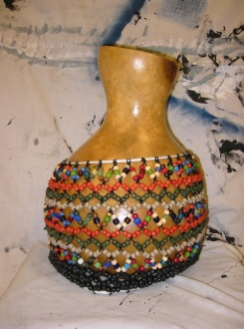
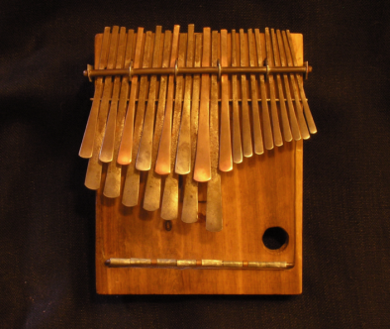
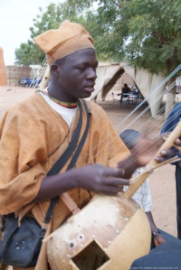
Mbira Shekere Kora

There are many different instruments in African music and they vary from region to region.
The many different types of drum are called membranophones (because they have a skin).
The other main types of instruments can be categorised as shown in the table below.

Idiophones (resonant/solid) | Aerophones  (Wind) | Chordophones  (Strings)

Throughout the piece there are 3 clear strands, answer the following question about these strands in as much detail as possible:

Describe the music played by the three different instrumental parts in the extract:

Balafons_________________________________________________________________________________________________________________________________________________________________________________________________________________________________________________________________________________________________________________________________________________________________________________________________________________________________________________________________________________________________________________________________________________________________________________________________________
__________________________________________________________________________

Drums____________________________________________________________________________________________________________________________________________________________________________________________________________________________________________________________________________________________________________________________________________________________________________________________________________________________________________________________________________________________________________________________________________________________________________________________________________________________________________________________________________________________________________________________________________________________________________________________

Voices____________________________________________________________________________________________________________________________________________________________________________________________________________________________________________________________________________________________________________________________________________________________________________________________________________________________________________________________________________________________________________________________________________________________________________________________________________________________________________________________________________________________________________________________________________________________________________________________

STRUCTURE
The piece is in three sections, follow the score (this is a transcription of the performance as they would have played from memory) and list what you can hear in each section:
Section | Instruments/Voices | Key Features/Techniques
Intro
Main section
Coda

Constant features which do not change throughout
- The tempo is unvaried
- The beat is regular and unvarying
- The drum ostinato persists throughout the music
- The pattern of voices followed by instrumental breaks
- The dynamics are largely unvaried

Full detailed structure

Section | Bar Numbers and timing | Analysis
Intro | 0.00-0.18  0.18-0.34 | - The piece starts in free tempo with a high balaphone improvised solo played at a soft dynamic level, setting the scene in a monophonic texture.  - The solo comprises a melody in Gb major with fast high and low rolls on every note.  - This is a simple and repetitive idea.  - A moderate tempo is established by the first balaphone as a second (lower pitched) balaphone joins in at the end of bar 9 playing mainly in octaves.  - There is a strong sense of major tonality as the opening two notes of the melody are dominant (Db) to tonic (Gb).  - The melody has a strong rhythmic basis too and is built on two-bar phrases.  - The second balaphone plays the same melody but with a few different pitches (see bars 11-12) in a heterophonic texture as the contours of the melody are roughly the same.  - The rhythms are mainly semiquavers and quavers with some tied notes.
 | 0.34-1.09 | - Large talking drum, small talking drum and djembe come in playing an insistent half-bar ostinato of quaver-two semiquavers-quaver-two semiquavers.  - Balaphones continue to play a melody which is a variation on the first melody.  - The lower balaphone plays an ostinato figure in bars 17-20.  - There are occasional djembe fills in this section of music too.  - The melody includes syncopated rhythms and lots of octave repetitions on the tonic note of Gb and the dominant note of Db.  - From bar 21 the simple melodic phrases are repeated with slight variation in short two-bar phrases.
Chorus A1 | 1.09-1.25 | - Voices in unison.  - Melody is short, simple and repetitive.  - The semiquaver-quaver-semiquaver rhythm is a feature of the vocal writing.  - No harmony.
Break | 1.25-1.44 | - Short instrumental for balaphone (solo break) and drums play continuous ostinati as before.
Chorus A2 | 1.44-2.01 | - Voices in for second verse (music much the same as before).
Break | 2.01-2.10 | - Voices out, then solo instrumental break on lower pitched balaphone.  - Some variation in balaphone melody (continuous semiquavers on Gb).
Solo with choral responses | 2.10-2.45 | - Solo with choral responses  - A solo voice (call).  - A dramatic and new melody features long held notes and short punctuated notes on 'Yiri'.  - The drum ostinato continues.  - Vocal melody now incorporates triplet figures.  - This again is a variation on the original melody.  - The lower pitched balaphone plays the same ostinato figure we heard at bars 17-20.  - Voices (choral response) in unison to call at bar 63.  - New melodic riffs in balaphones based on original.
 | 2.45-3.14 | - Solo voice (call) again featuring long held notes.  - Drums continue as before.  - Balaphone now plays a rhythmic three-note semiquaver melodic figure creating cross-rhythms.  - Bar 71 features the solo voice again singing yet another variant of the melody.  - The triplet idea, syncopated rhythms and semiquaver-quaver rhythms heard before in the music all feature here too.
 | 3.15-3.19 | - Vocal response from the choir in unison.
 | 3.20-3.28 | - Solo voice (call) with some varied balaphone rhythms in a solo break.
 | 3.28-3.59 | - Instrumental solos carry on.  - New melodies on the balaphones.  - Short three-beat (one-bar) rest before we have the next chorus.
Chorus B1 | 4.00-4.31 | - Full choir in unison singing 'Yiri' with some short instrumental interjections to break up vocal lines.
 | 4.31-4.45 | - Dialogue effects between voices and instruments
 | 4.45-5.20 | - Instrumental as a balaphone break.  - Riffs with variations.  - This is quite extended and is based still on the original melody with variations.  - This is more virtuosic with rapid figuration featuring octave leaps and semiquaver and demisemiquaver patterns.
Chorus A3 | 5.20-5.36 | - Full choir again in unison with instrumental interjections
 | 5.36-6.24 | - Instrumental ending played as a balaphone break.  - This is very syncopated and the drums re-enter at bar 153, one bar before the coda.
Coda | 6.24 to end | - Five two-bar phrases mostly in octaves end with dramatic rests observed by all instruments.  - This has the sense of a strong riff.  - There are some differences in notes on occasions (see bars 154-end) creating an heterophonic texture.  - Drums provide the familiar ostinato from bar 153.  - The piece finally concludes with a single 'ting' on the bell.

MELODY, HARMONY AND TONALITY
Yiri is in the key of Gb major without the F, this leaves only six notes which means that it is based on a hexatonic scale.
The balafons play short patterns that tend to emphasise the Gb and the Db – what notes of the scale are these? _________________________________________________________________
During the choruses the group sings together in unison.
It is entirely diatonic throughout.
RHYTHM, METRE AND TEMPO

The main metre is ____________. There are however a few bars with other metres.

After the introduction which is free tempo the rest of the piece has a steady pulse.

There is frequent use of syncopation throughout. During the second solo voice section there is an example of cross rhythms where the balafon is playing semiquavers in groups of threes. There are also triplets being used in the solo voice part.

The drums play a rhythmic ostinato throughout.

TEXTURE AND DYNAMICS

Most of Yiri has a layered texture, but it does include monophonic texture in the introduction and occasional heterophonic textures. This final texture is created when the balafons play different versions of the same tune at the same time.

There is little dynamic variation in the piece.

AoS 4
Koko: ‘Yiri’

Terms | Definitions
Ostinato
Improvisation
Cross rhythm
Polyrhythm
Syncopation
Master drummer
Balaphones
Mbira
Djembe
Donno
Dundun
Vocables
Oral tradition
Griot

