Area of Study 4 – Set Work 12

World Music

Area of Study 4 – Set Work 12
Capercaillie- Skye Waulking Song

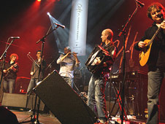

Capercaillie
- A Scottish Band
- Formed in 1983 at Oban High School to play for local dances called ceilidhs
- First album recorded in 1984
- Play Celtic Fusion music – Celtic folk music combined with elements of pop music
- Much of their music is recorded in Gaelic
- Have also recorded music for TV and films including Rob Roy

Capercaillie: Skye Waulking Song (2000)
Facts..........

- has a 12/8 time signature
- is mostly based around three chords – C, E minor and G
- has eight verses and an instrumental section
- opens with an intro and fades out with an outro
- is from a collection of Gaelic folk songs compiled by the folklorist Alexander Carmichael
- Lead singer, Karen Mattheson, has an unusually low female alto voice
- combines folk and rock instruments
- a waulking song is a work song, sung by women workers processing cloth.
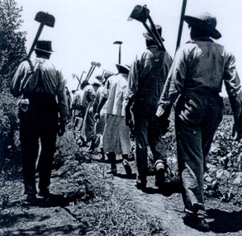
The Role of Music in the Work Place
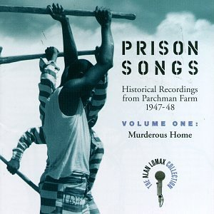
A work song is typically a rhythmic a cappella song sung by people working on a physical and often repetitive task. The work song is probably intended to reduce feelings of boredom. Rhythms of work songs also serve to synchronize physical movement in a gang. Frequently, the usage of verses in work songs are often improvised and sung differently each time. The improvisation provided the singers with a sometimes subversive form of expression: improvised verses sung by slaves had verses about escaping; improvised verses sung by sailors had verses complaining about the captain and the work conditions. Work songs also help to create a feeling of familiarity and connection between the workers.
Work songs sung by slaves are known by many names around the world. In America, such songs were the foundation for what would eventually become the Blues. Some songs were part of a native heritage and sung to remind the slaves of home, while others were instituted by the slave masters to raise morale, keep slaves working in rhythm, or any number of other purposes. Black American slave songs might be referred to as "chain gang songs" or "spirituals" depending on the context of the song. An example of a slave work song would be “Swing Low, Sweet Chariot”.
Work songs sung by sailors during the 20th, 19th, and to a lesser extent 18th centuries are known as sea shanties. These songs were typically performed while adjusting the rigging, raising anchor, and other tasks where men would need to pull in rhythm.
These songs usually have a much punctuated rhythm precisely for this reason, along with a call-and-answer format.
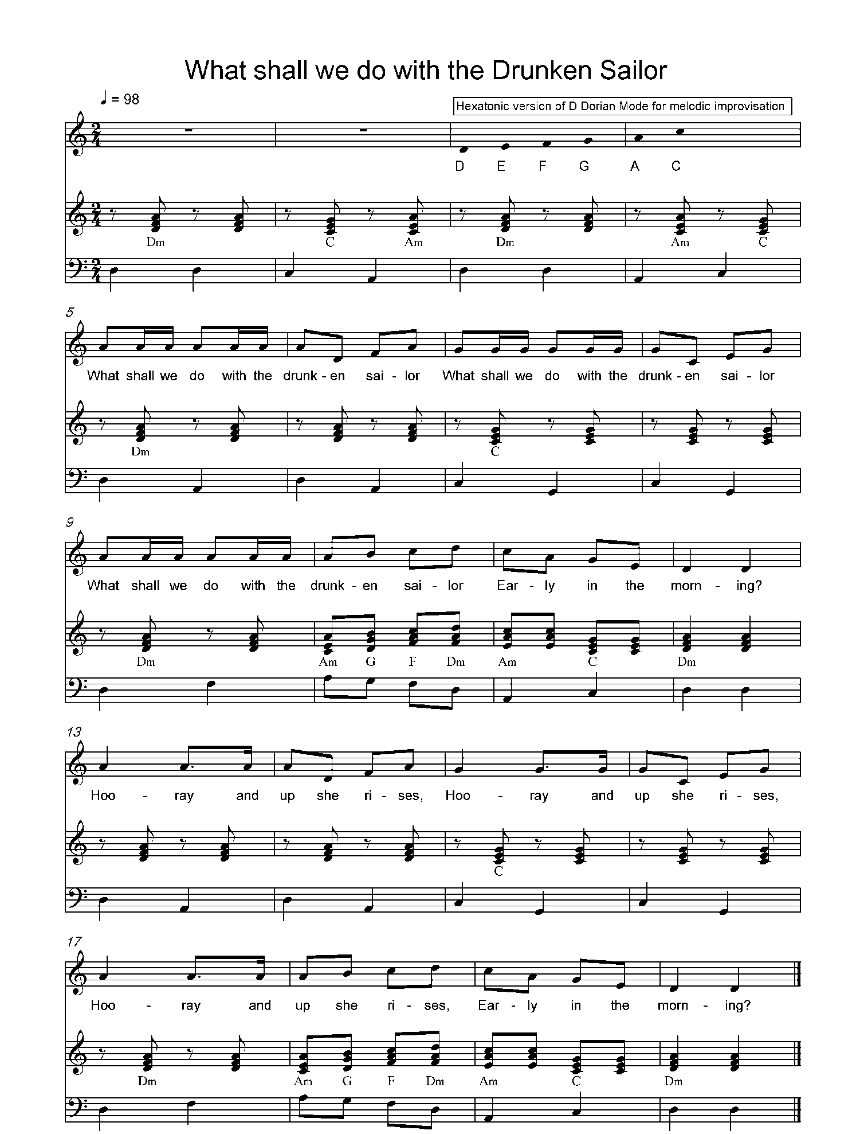
Well before the 19th century, sea songs were common on rowing vessels. Such songs were also very rhythmic in order to keep the rowers together. Because many cultures used slaves to row, these songs might also be considered slave songs. These songs were performed with and without the aid of a drum. Shanties had a very slow style and ere sometimes accompanied by an accordion or concertina. (NB For info only!)
The Skye Waulking Song is an example of a Work Song, as in our women waulking the cloth in the Scottish Isles. “Waulking” is a process of repeatedly beating the cloth to full it and prepare it for use. The process is called "orain luaidh" in Gaelic.
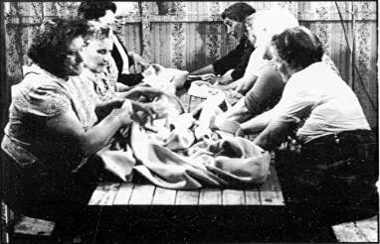
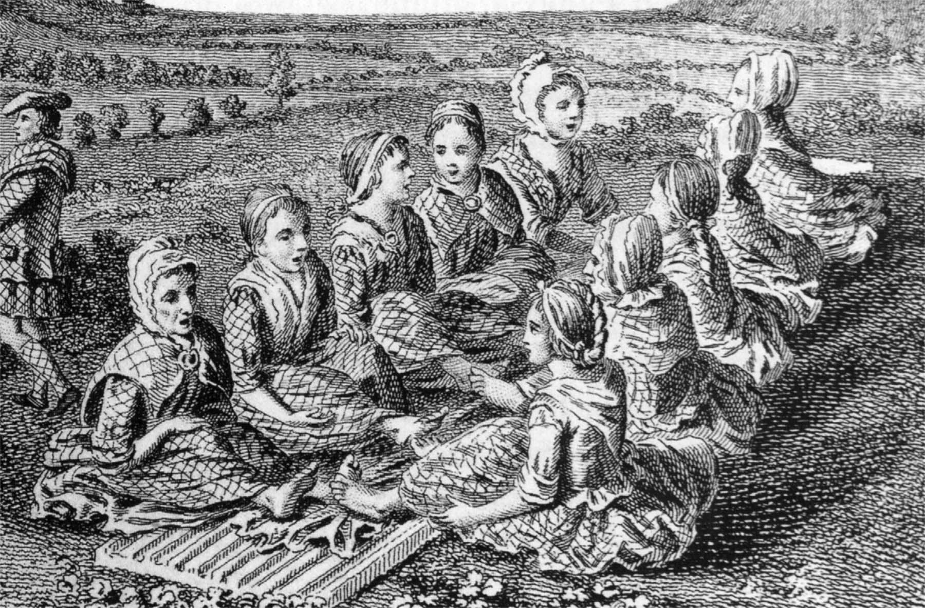
The music associated with this labour contains vivid and intimate personal poetry, mostly the composition of women. The songs helped the women to move the cloth in time with each other, they pounded the tweed cloth against a wooden board called the waulking board, in order to soften it and make it more air tight. The women would sit for many hours working the tweed. This tradition continued in Scotland until the early 1950s. The songs were usually in a call and response form; the call was made by a soloist and the response by every one else.

Listen to the extract which contains a call and response from the set work.

Call:
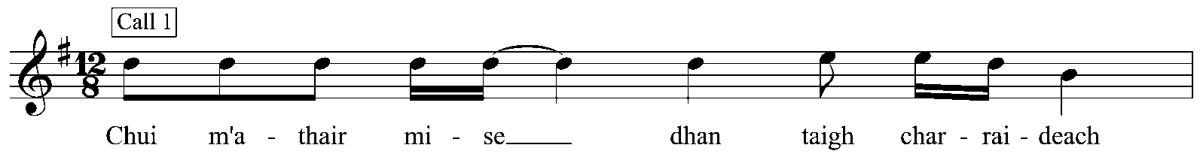
Response:
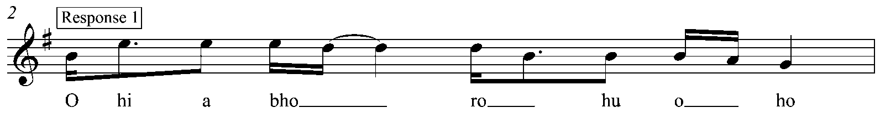

What you have identified above is what is known as Phrase 1 and Refrain 1. Where else can you see these within the Skye Waulking Song?
____________________________________________________________________________________________________________________________________________________________________________________________________________________________________________________________________________________________
What do you notice about this pattern?
_____________________________________________________________________________________________________________________________________________________________________________________________________________________
Are there any other repeating patterns within this set work? If so where?
_____________________________________________________________________________________________________________________________________________________________________________________________________________________

STRUCTURE

What you may have noticed is that the vocal line alternates between four separate phrases, each one lasting for one bar. This is in a call and response form.

Fill in the missing notes below:
Phrase 2:
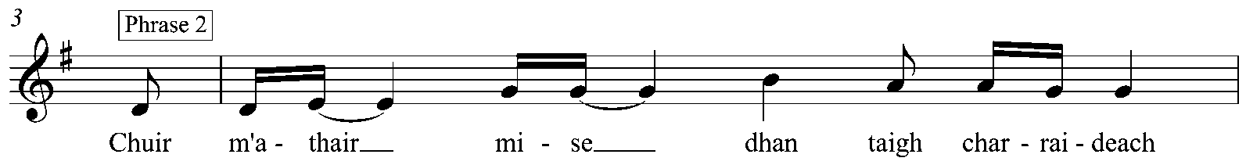
Refrain 2:
____________________________________________________________________________________________________________________________________________________________________________________________________________________________________________________________________________________________________________________________________________________________________________________________________________________________________________________________________________________________________________________________________________________________________________________________________________________________________________________________________________________________________________________________________________________________________________________________________________________________________________________________________________________

The overall structure therefore is:

Section | Bar
Intro | 1-8
Verse 1 | 9-11
Break | 12-15
Verse 2 | 16-20
Verse 3 | 21-24
Verse 4 | 25-28
Verse 5 | 29-32
Verse 6 | 33-36
Instrumental | 37-43
Verse 7 | 44-48
Verse 8 | 49-52
Outro | 53-end

Some may even say that this piece has only two verses and would argue that the structure is as follows:

Intro | 1-17
Verse 1 | 18-33
Verse 2 | 34-51
Outro/Fade out | 52-65
INSTRUMENTATION AND TEXTURE

As mentioned earlier this is a Celtic Fusion piece that combines traditional with more modern instruments. Here are some of the more traditional instruments used in this piece:
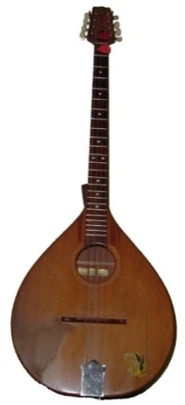
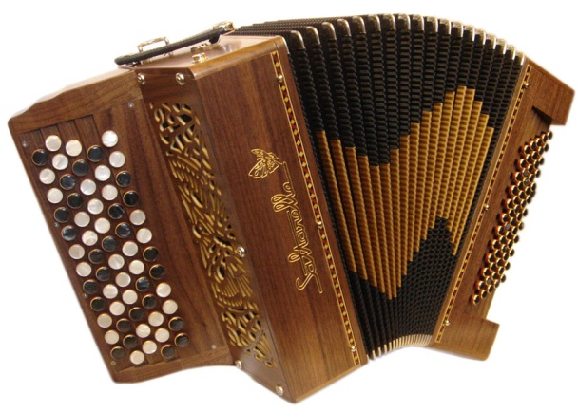
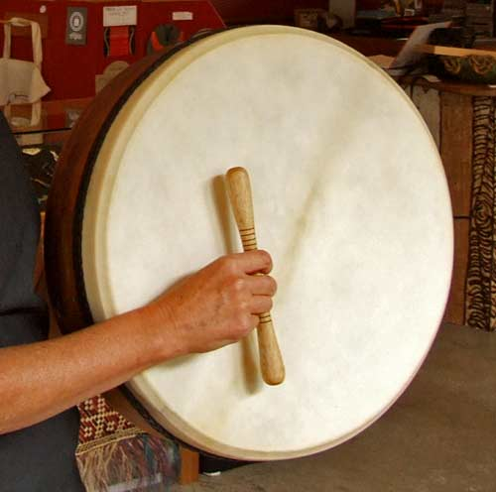

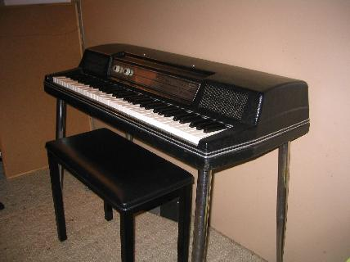
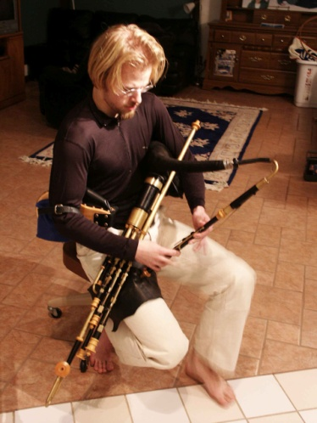

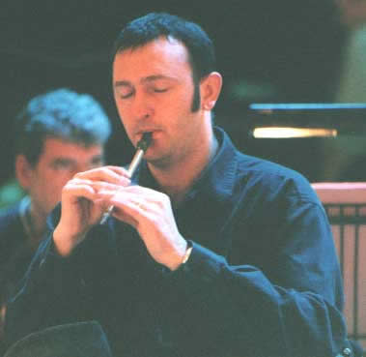

Label the pictures using the names given below:
Uilleann Pipes Accordian Tin Whistle Bouzouki Bodhran Wurlitzer (electric) Piano
What instruments can you hear that give the music a more modern feel?
____________________________________________________________________________________________________________________________________________________________________________________________________________________________________________________________________________________________
A layered texture is created throughout:
Rhythm pattern | Drum kit
Bass line | Bass guitar
Chords | Synthesiser
Main Melody | Voice
Countermelodies | Other melody instruments: violin, Wurlitzer piano, uilleann pipes and bouzouki

There is one point in the piece where the accompaniment drops out completely, where is this and how is it indicated in the score? ______________________________________________________________________________________________________________________________________________

At the start there is a cluster chord played by the synthesiser, this is when notes are played very close together and therefore create a dissonant sound. It is played ‘with modulation’ which means that a modulation effect is applied to the synthesiser that fluctuates the pitch slightly, like a vibrato effect (NB not to be confused with changing key).
What playing technique is being used by the fiddle at the very start of the song? Describe the sound in as much detail as you can.
_____________________________________________________________________________________________________________________________________________________________________________________________________________________

The melodic lines are played in a folk style – the instruments improvise around the main melody simultaneously, sometimes playing a very similar melody in slightly different ways – heterophonic texture – and sometimes weaving a complex, improvised counterpoint around the melody and the scale.

MELODY

The vocal melody is pentatonic (G A B D and E) and uses the lower register of the voice. Karen Mattheson’s part is notated using the vocal tenor clef, which means that the voice sounds an octave lower than printed.

Is the text mainly syllabic or melismatic? ______________________________________
What language is the song in? ________________________________________

The instrumentalists play short motifs and countermelodies mostly based on the vocal phrases.

RHTYHM AND METRE
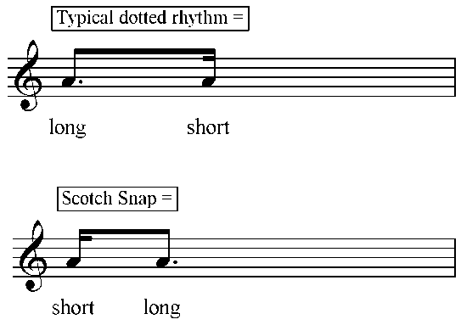
The song is in compound quadruple time, what does this mean? _____________________

Key rhythmical features within this piece are the use of syncopation, cross rhythms and the scotch snap (lombardic rhythm).

HARMONY

In this style of music harmony is less important than the melody and rhythm. The harmony is very simple throughout the song using predominantly three chords: G, Em and C. The changes in chord sequences are infrequent but this does mean that when a change does occur it highlights a different section or mood within the song. The song is in G major but the distinct lack of the dominant chord gives this piece a modal feel. It is entirely diatonic throughout.

EXAM QUESTION

Here is an example of an exam question related to this set work:

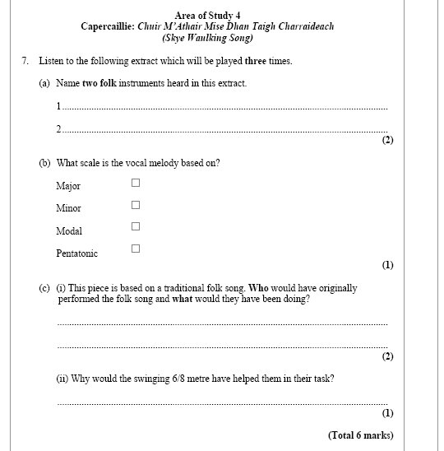

The examiner would be looking for these answers:
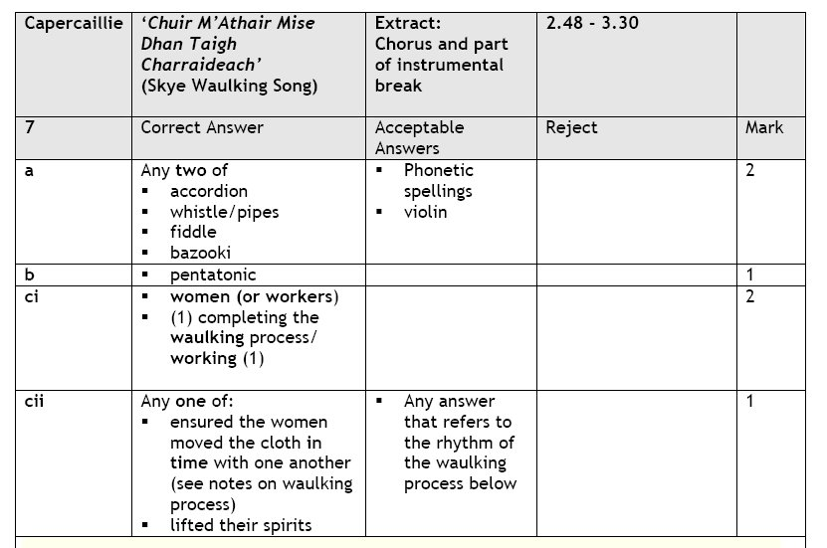

How many did you get right? ___________________

Capercaillie – Skye Waulking Song

Task 1 – Instruments:
Describe the instruments used in Capercaillie and how they demonstrate fusion. Remember to state what fusion is and how it is used specifically in this piece (4 marks).
____________________________________________________________________________________________________________________________________________________________________________________________________________________________________________________________________________________________

Task 2 – Analysis
Using the analysis sheets you have been given, complete the following table and then answer the questions below.
Musical feature: | Where you can find it…
Texture:
- Counterpoint
- Homophony
- Heterophony
Key signature/Harmony:
- Hinting at the key of E minor
- Chord sequence established as Em-G
- Chord sequence changes to C-G-Em-G
- Chord sequence changes to Am7-Em-Em-G
- Chord sequence alternates between C-G
Time signature:
- Ambiguous
- Starting to establish itself as 12/8
- Clearly 12/8
Ornamentation/Instrumentation:
- Tremolo
- Cluster chord
- Accordion enters
- Accordion playing countermelodies
- Strumming of the electric guitar and the bouzouki
- Uillean pipes heard
- Fiddle concentrating on effects

Describe the outro, considering texture, instrumentation, use of vocals and harmony. ____________________________________________________________________________________________________________________________________________________________________________________________________________________________________________________________________________________________________________________________________________________________

Questions:

- What is tremolo? _________________________________________________________________
- Which two instruments play in counterpoint at the start of the piece? _________________________________________________________________
- What does the first line of the verse translate as? __________________________________________________________________________________________________________________________________
- Which instrument is most prominent in the bridge? __________________________________
- When does the 12/8 time signature start to be set? ____________________________________
- How does the playing of the acoustic guitar and bouzouki change in verse 4? _________________________________________________________________
- Describe the accordion part in the instrumental: __________________________________________________________________________________________________________________________________
- Describe the use of texture in verses 7 and 8: ___________________________________________________________________________________________________________________________________________________________________________________________________
- Describe the cultural context of this song and how the music shows this. You should include:
  - The country of creation
  - The purpose
  - The musical features of a waulking song and how they support the purpose
  - How the musical features are shown in ‘Skye Waulking Song’
(12 Marks)
______________________________________________________________________________________________________________________________________________________________________________________________________________________________________________________________________________________________________________________________________________________________________________________________________________________________________________________________________________________________________________________________________________________________________________________________________________________________________________________________________________________________________________________________________________________________________________________________________________________________________________________________________________________________________________________________________________________________________________________________________________________________________________________________________________________________________________________________________________________________________________________________________________________________________________________________________________________________________________________________________________________________________________________________________________________________________________________________________________________________________________________________________________________________________________________________________________________________________________________________________________________________________________________________________________________________________________________________________________________________________________________________________________________________________________________

AoS 4
Capercaillie: Skye Waulking Song
Terms | Definitions
Waulking songs
Uilleann pipes
Fiddle
Accordian
Bouzouki
Scotch snap
Call and Response
Pentatonic
Cluster chord
Counter melody
Fusion
Waulking

Gaelic

Tremolo

Heterophonic texture

Lament

