Area of Study 2 – Set Work 6

Reich

Electric Counterpoint: 3rd movement- FAST (1987)
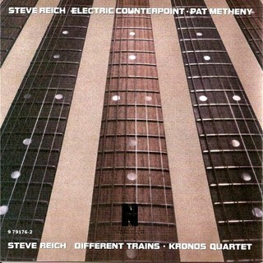

Minimalism

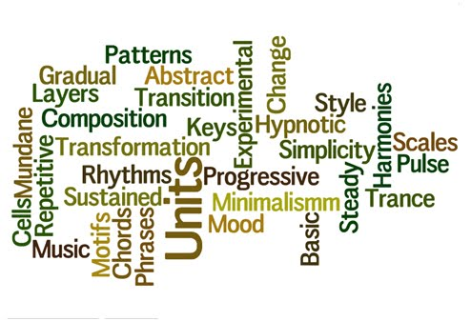

- In the 1960’s artists, sculptors, musicians and writers began reacting against this culture of expressing extreme emotions

- They began producing works that were stripped down to their
bare essentials, deliberately removed from self expression

- Minimalism was born..........listen to It’s Gonna Rain by Steve Reich, this is the birth of drum’n’bass!!!!
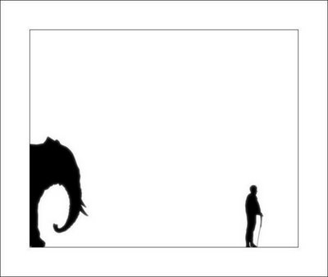
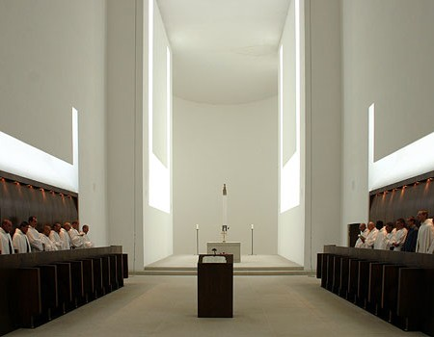

Features of Minimalist Music

- 4 main composers- Terry Reilly, La Monte Young, Steve Reich and Philip Glass
- Drones – a continuous note or repeated note
- Ostinati/loop – repeated patterns (called cells)
- Phase Shifting – 2 mostly identical parts when repeated together they go out of sync and gradually back into sync

Steve Reich wrote two works that use this feature – Clapping Music and Piano Phase
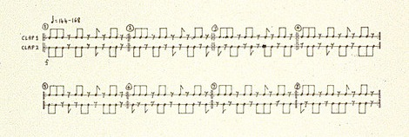

- Metamorphosis – gradually changing ideas (e.g. changing one note at a time)

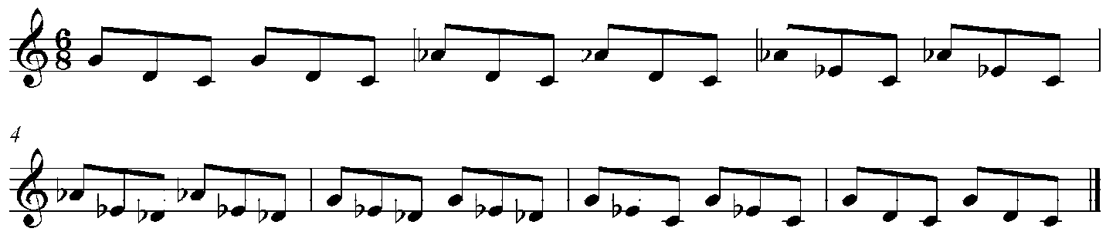

- Addition – adding in new notes
- Subtraction – taking away notes
- Augmentation – doubling the length of notes e.g. crotchet = minim
- Diminution – halving the length of notes e.g. crotchet = quaver
- Static Harmony – chords change very slowly, if at all
- Diatonic harmony
- Layering – adding new musical parts – creating a complex texture
- Resultant Melody – using different layers playing different melodies to create a new melody which appears “floats” over the top

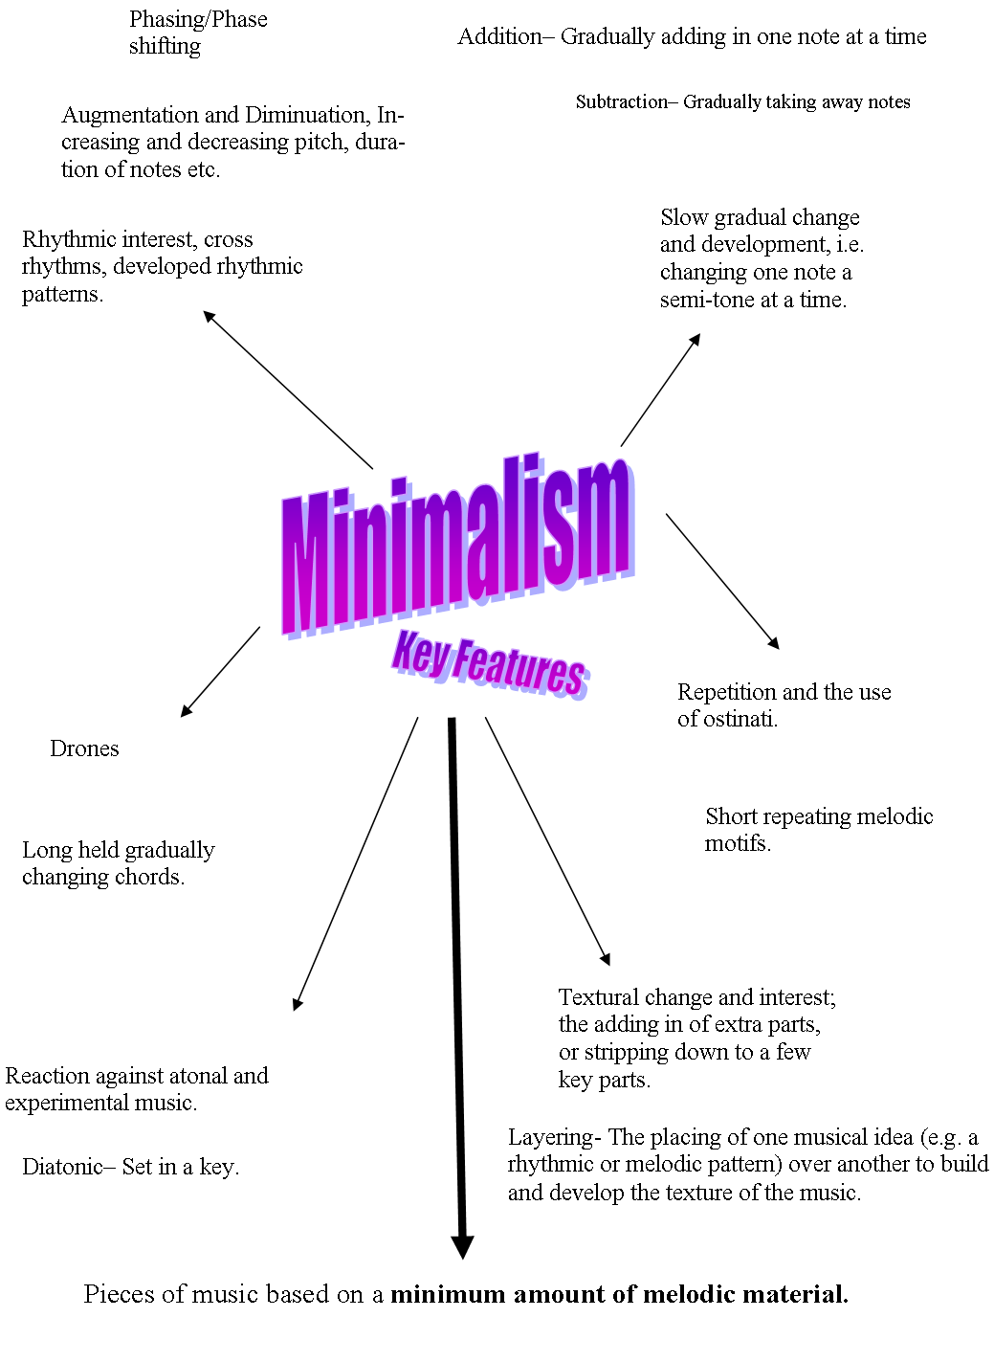
Identify on the score below where you see these features occurring:
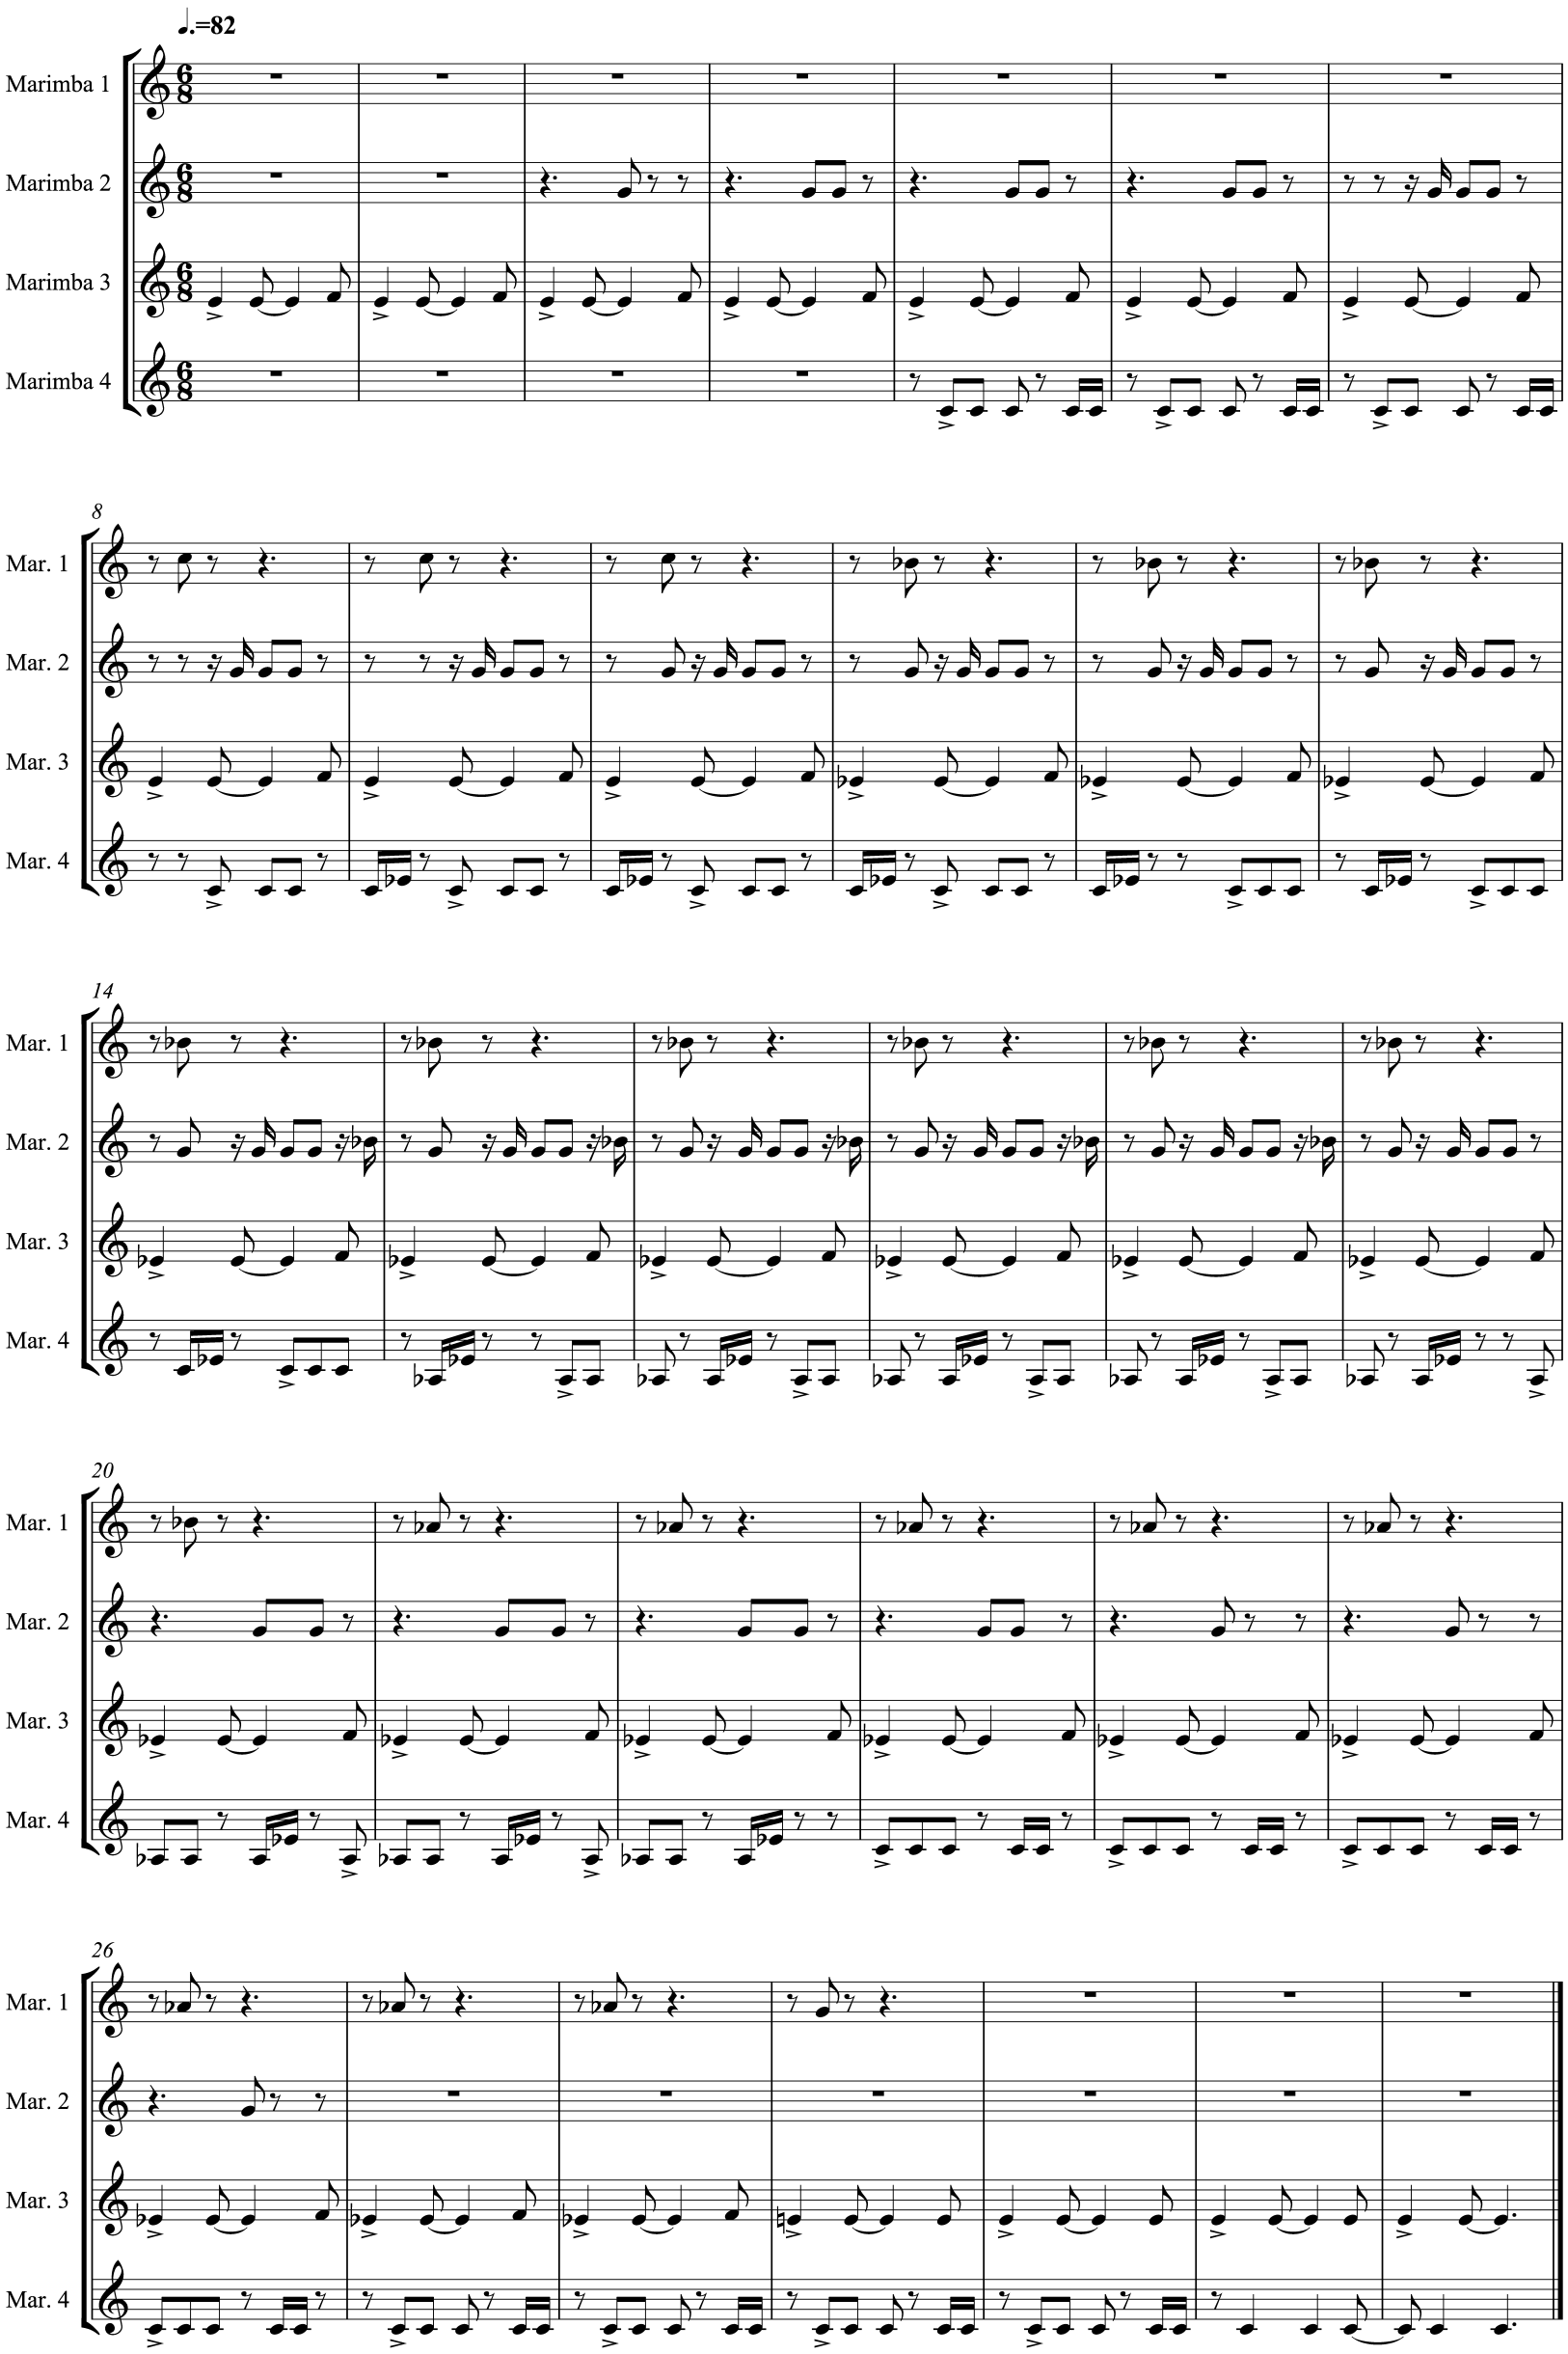
Terry Riley: In C
Look at this piece and learn the different cells, prepare a class performance.
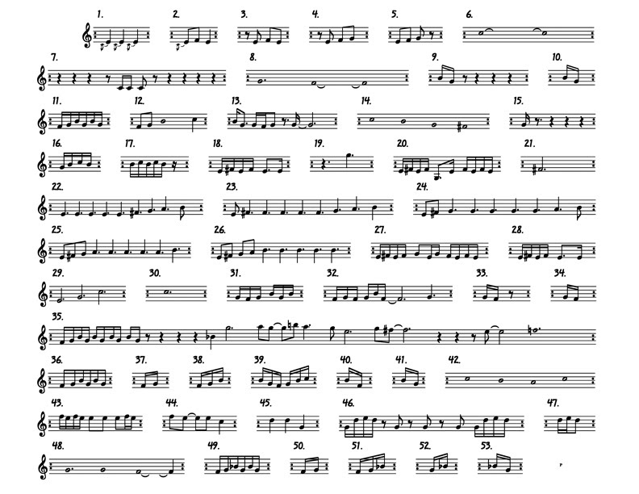
Identify the following minimalistic techniques and write down the cell where it takes place.
Phase shifting __________________Augmentation _____________________

Note addition __________________Diminution _________________________

Note subtraction _________________
Steve Reich

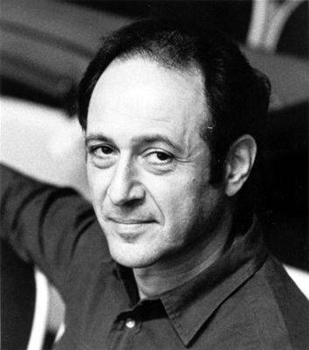

- Born in New York 1936
- Studied Philosophy and composition
- Performed in Terry Riley’s ensemble before creating his own
- Studied African drumming in Ghana in 1970
- Studied Balinese Gamelan in 1973-4 – influenced his use of mallet instruments
- Reich’s music is rhythmically complex and very repetitive

List 4 other facts about Reich’s Electric Counterpoint including who it was written for:

- ____________________________________________________________________________________________________________
- ____________________________________________________________________________________________________________
- ____________________________________________________________________________________________________________
- ____________________________________________________________________________________________________________

Electric Counterpoint: third movement (1987)

- Written for soloist and a pre-recorded backing track
- Third in a series of such works – Vermont Counterpoint (1982) for flute and New York Counterpoint (1985) for clarinet
- Written in 3 movements - Fast – Slow – Fast
- We are studying the last movement
- Electric Counterpoint was written for Jazz guitarist Pat Metheny
- The 3rd movement has 7 guitar and 2 bass parts that are pre-recorded as a multi-tracked backing track
- Solo guitar plays live over the top
- This is a way for a solo performer to perform as an ensemble with himself
- Diatonic throughout

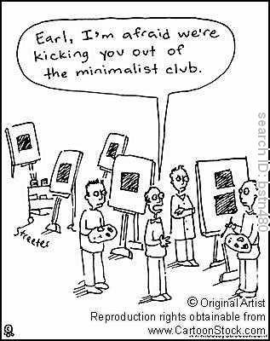
Electric Counterpoint, like other minimalist pieces, has influenced pop musicians. Listen to the Orb’s Little Fluffy Clouds (1990); they have used an extract from this third movement in this track.

INSTRUMENTATION
How many pre-recorded guitar parts are there? ___________________________________

Who is the performing the live guitar part on this track? ____________________________

In order to blend well with the track the live guitar is amplified.

STRUCTURE

Minimalism rarely uses formal structures such as ternary or rondo form, this is due to its repetitive gradual evolution. This piece loosely falls into three main sections although they are very similar:
Section | Features | Bar
A | Em, hexatonic, gradual addition of layers.
B | First key change to Cm.  B section is signified by regular key and metre changes.
Coda | Returns to ‘simple’ four part canon with no accompaniment and constant 3/2 metre.

MELODY AND TEXTURE

In order to understand Reich’s use of the melody let’s look at the opening section. The movement opens with a one bar syncopated motif. This forms an ostinato that is heard continuously until bar 73. The motif is hexatonic – what does this mean? ______________________________________________________________
Name the notes that he uses in this pattern: _______________________________________

The entire movement is constructed in layers, starting with a monophonic texture that gradually builds up to a four-part canon creating an imitative texture for the remainder of the piece.

Let’s break section A down:
Instrument | Bar | Ostinato | Minimalist Technique
Guitar 1 | 1 | One bar motif repeated continuously | Ostinato
Live guitar | 2 | 3 notes of ostinato 1 building up to the full ostinato pattern in bar 6 | Note addition
Guitar 2 | 7 | Ostinato 1 | Phase shifting
Guitar 3 | 10 | Building up ostinato 1 but with an additional note and a phase shift of 5½ beats | Note addition and  Phase shifting
Guitar 4 | 16 | Ostinato 1 - in unison with the live guitar | Phase shifting
Live Guitar | 20 | New ostinato pattern built from ostinato 1 | Resultant melody
 |  |  | All guitars combined to create static harmony

The live guitar at bar 20 reinforces the resultant melody – Reich used this technique in many of his compositions. The interweaving of the parts causes certain notes to leap out at the listener, almost like a melody but with the notes shared across the instruments. The live guitar part reinforces this by playing the notes on one instrument.

RHYTHM, METRE AND TEMPO

What is the tempo of this piece? _______________________________________________

The main metre of this piece is _______________________

Describe what happens to the metre at bar 82 and the impact that this has on the music rhythmically:
________________________________________________________________________________________________________________________________________________________________________________________________________________________________________________________

Rhythm is an important feature, Reich’s experience of African music can clearly be heard within this piece particularly with the use of cross rhythms and syncopation.

Changes in metre (time signature) between 3/2 (3 minims per bar) and 12/8 (12 quavers per bar). Rhythmic counterpoint (different rhythms happening at same time).

HARMONY AND TONALITY

There is much tonal ambiguity (keeping the key uncertain) in this piece. The music is entirely diatonic, the main ‘A’ section contains only 6 notes from the G major scale. This type of scale is called a hexatonic scale because it only uses six notes:
- G A B D E F# -

However the tonal centre of this piece appears to be the bass note E. Steve Reich is using a G major scale but with an E as his root note, this concept is known as modality. This piece is therefore in E modal minor – E F# G A B D (E).

It modulates to a pentatonic (5 note) version of the Eb major pentatonic - Eb F G Bb D, but the bass guitars and chords mainly use the C minor tonality so the new key feels and sounds like C modal minor - C D Eb F G Ab Bb (C). This mode uses the notes of the Eb major scale but starts on a C.

DYNAMICS

The dynamics remain fairly constant throughout, though parts do fade out in a number of places.

AoS 2
Reich: ‘Electric Counterpoint’: 3rd movement
Terms | Definitions
Ostinato
Cells
Loop
Phasing
Note addition
Note subtraction
Augmentation
Diminution
Layering
Resultant melody
Modal
Polymetre
Hexatonic scale

