Area of Study 4 – Set Works 9

World Music

Area of Study 4 – Set Works 9

Rag Desh

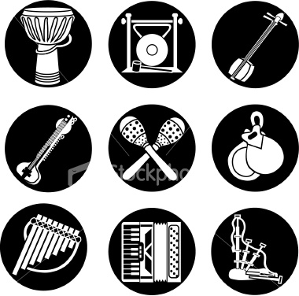

Content coverage | Learning outcomes
Indian Music: ‘Rag Desh’ (AoS 4)  Listen to the performances of ‘Rag Desh’ by Anoushka Shankar, Chiranji Lal Tanwar and Steve Gorn/Benjy Wertheimer.  Make connections between the performers’ use of the Rag and the use of modes by Davis et al. | - To develop students’ understanding of improvising techniques in the context of Indian music.  - To look at alternative approaches to the use of melody and harmony.  - To understand the role of the drone, rag and rhythmic tala in Indian music.  - To be able to compare the different realisations of the rag, understanding why the same rag can be interpreted so differently and expressing their findings using appropriate musical vocabulary.
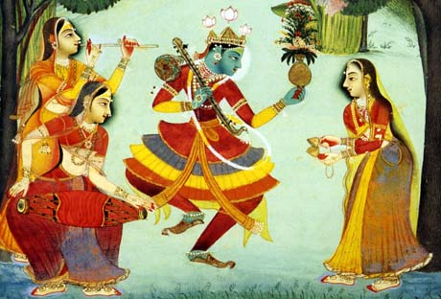

Indian Music
Rag Desh is an example of North Indian classical music. It is an improvised form of music with a long history. The improvisations take place within well defined structures and conventions. The music is taught by respected teachers called gurus who pass their knowledge down through oral tradition.
North Indian or Hindustani classical music is built on two basic elements: rag (scale) and tala (rhythms). A rag is both the name of the completed piece and the pattern of notes within that piece. Three parts to the music are heard:
- Drone
- Rhythm (based on the tal)
- Melody (based on the rag)
- The tal or tala is a repeating rhythm pattern usually played by the table
- It usually has between six and sixteen beats
- The beats are grouped into bars(vibhags)
- The first beat of the cycle is known as sam, it marks the beginnings and ends of improvisations so it is often accented.
- Weaker beats are often shown by a wave of a hand instead of a clap (often by the audience) and is know by khali (empty).
- Each tal uses a pattern of drum strokes (bols) know as theka, bols can be represented by sounds using the voice

Tintal is the most common tal. It has the following characteristics:

- sixteen beats/mantras
- Broken up into 4 vibhags (4 + 4 + 4 + 4)
- four sections beginning on the 1st, 5th, 9th and 13th beats

It is common to mark tala by hand claps and waves. In tintal the beginning of the first, second and fourth sections is marked by a clap, but the beginning of the third section is weaker and this is shown by a wave of the hand.

Beat number | 1 | 2 | 3 | 4 | 5 | 6 | 7 | 8 | 9 | 10 | 11 | 12 | 13 | 14 | 15 | 16
Action | Clap |  |  |  | Clap |  |  |  | Wave |  |  |  | Clap
Vocal mnemonic | Dha | Din | Din | Dha | Ta | Din | Din | Dha | Ta | Din | Din | Ta | Ta | Din | Din | Dha

The actions (clap and wave) are visual indications used by the tutor to help show where you are within the Tal.
The different words of the vocal mnemonics: Dha; Din; and Ta represent the type of sound that the Tabla player is trying to get out of the drums by hitting them on different parts of the skin and with different parts of the hand.
A rag is a fixed scale although it is sometimes different going up and coming down. Rags are associated with moods, e.g. loneliness, bravery, eroticism, and with particular times of day or year, or with certain ceremonial occasions.
The Rag used in these three examples is the Rag Desh, this is a late evening rag associated with the monsoon season. In Indian music a system known as sargam is used for naming the notes: Sa, Re, Ga, Ma, Pa, Dha, Ni, Sa. The tonic, or ground note, is Sa (this is heard in the drone).

Rag Desh

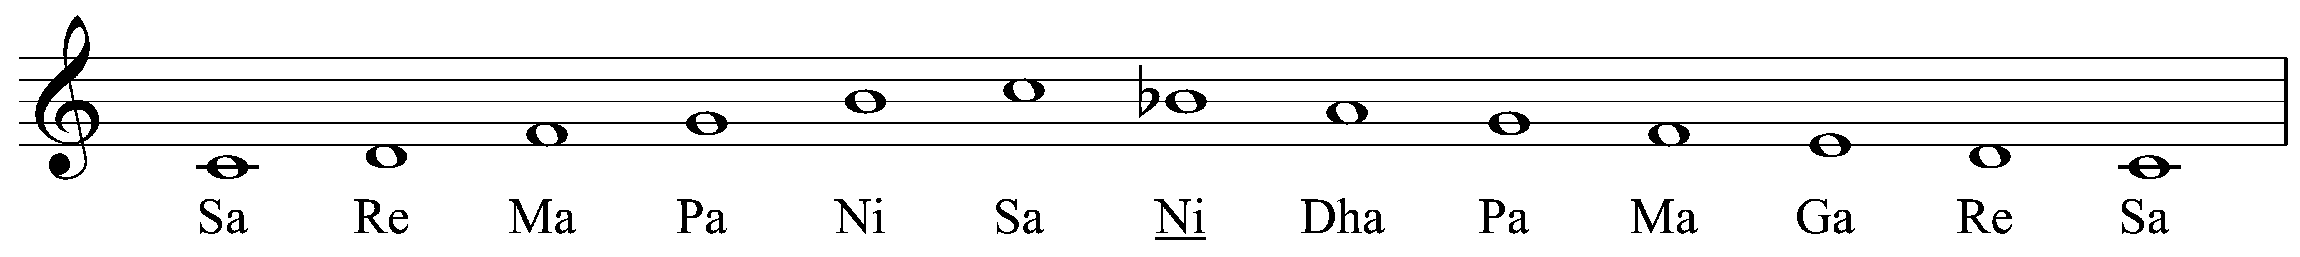

INSTRUMENTS
It is also very important to identify the instruments used when listening to the three set works:
Sitar
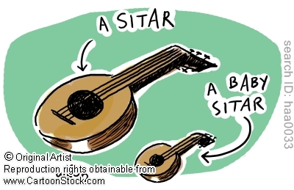

The Sitar is perhaps the most well known of the Indian instruments. Artists such as Ravi Shankar have popularized this instrument around the world. The Sitar is a long necked instrument with a varying number of strings but 17 are usual. It has three to four playing strings and three to four drone strings. These strings are plucked with a wire finger plectrum called mizrab. There are also a series of sympathetic strings lying under the frets. These strings are almost never played but they vibrate whenever the corresponding note is sounded. The main resonator is usually made of a gourd and there is sometimes an additional resonator attached to the neck.
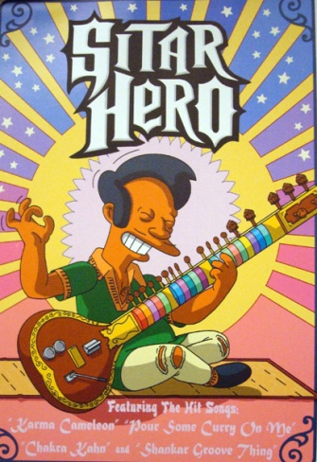
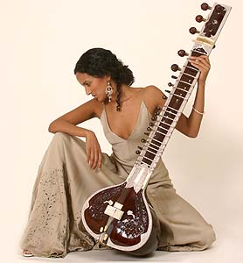

Sitar

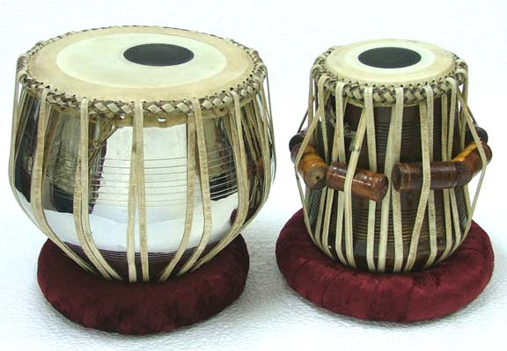
Tabla
The Tabla is a pair of drums. It consists of a small right hand drum called dayan and a larger metal one called bayan. The dayan (right hand drum) is almost always made of wood and is tuned to the root note or sa of the raga. The bayan (left hand drum) is usually made of brass with a nickel or chrome plate. Undoubtedly the most striking characteristic of the tabla is the large black spot on each of the playing surfaces. These black spots are a mixture of gum, soot, and iron filings. Their function is to create the bell-like timbre that is characteristic of the instrument.
A tabla player will bend notes by increasing the skin tension with part of the hand in order to create the “twang” sound that gives the tabla its distinctive character. Tabla playing is very difficult and it can take years to master the different strokes (bols). Some strokes are open (allowed to ring) and others are closed (dampened).

Go to http://www.youtube.com/watch?v=Joyk_EMtzn0
(Ravi Shankar, Alla Rakha – Tabla Solo in Jhaptal – uploaded by ganchans)
Watch at least 6 minutes of the clip.

Observe how the player changes the pitch and timbre of the 2 drums by hitting them with different parts of his hand.

Other Instruments

Pakhawaj – a double barrelled drum.
Sarangi – a bowed string instrument.
Swarmandal – a zither harp that is plucked, the strings are tuned to the notes of the rag to provide an ambience of the raag.
Tambura – a stringed instrument which provides a drone. The tambura is often mistaken with the sitar. The major difference between the two is that the sitar has frets.
Sarod – a plucked string instrument; the metal fingerboard is fretless and a coconut wood plectrum is used to strike the strings
Bansuri - an Indian flute which is typically made of bamboo or reed with holes cut into it.
Shruti box – an electronic instrument that plays the drone.
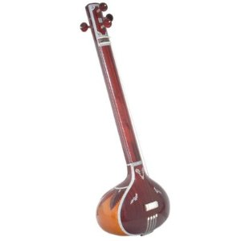
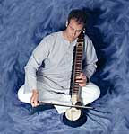

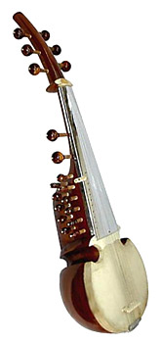
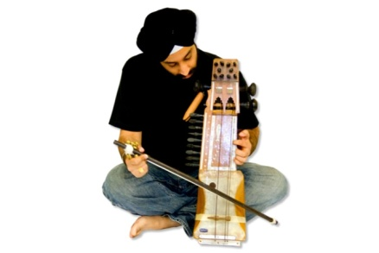
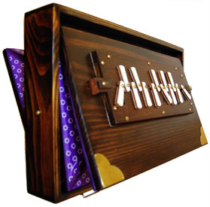

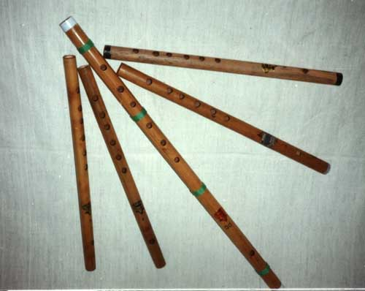

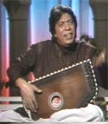
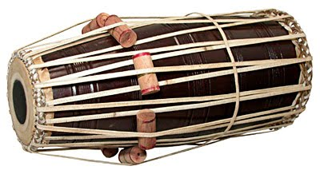

STRUCTURE

It is very important that the structure can be recognised. A typical performance of a raga is divided into four main sections:
- the alap
- the jor
- the jhalla
- the gat / bandish
In a piece of Indian music the sections maybe omitted but will have an alap and gat/bandish as minimum.
Raga pieces can vary vastly in time from 20-30 minutes to over 5 hours with 90-95% of the piece being improvised.
Section | Tempo | Metre/rhythm | Musical Features
Alap

Jor

Jhalla

Gat/ Bandish

Set Work: Rag Desh (3 settings)

Listen to the three Rag Desh pieces and identify what instruments you can hear in each one.

Instruments
Rag Desh performed by
Anoushka Shankar (2001)

Mhara janam maran performed by Chiranji Lal Tanwar (2004)

Rag Desh performed by
Steve Gorn and Benjy Wertheimer (2004)

Homework:

Write a brief paragraph about each of the performers above.

Anoushka Shankar
________________________________________________________________________________________________________________________________________________________________________________________________________________________________________________________________________________________________________________________________________________________________________________________________________________________________________________________________________________________________________________________________________________

Chiranji Lal Tanwar
__________________________________________________________________________________________________________________________________________________________________________________________________________________________________________________________________________________________________________________________________________________________________________________________________________________________________________________________________________________________________________________________________________________________________________________________________________________

Steve Gorn and Benjy Wertheimer
____________________________________________________________________________________________________________________________________________________________________________________________________________________________________________________________________________________________________________________________________________________________________________________________________________________________________________________________________________________________________________________________________________________________________________________________________________________________________________________________________________________
____________________________________________________________________________________________________________________________________

Write down a summary of the rhythm and structure of all three Indian pieces:
Title | Tal pattern (Rhythm) | Structure | Key Terms
Rag Desh performed by  Anoushka Shankar (2001) |  |  | Meends – pitch bends and slides  Tihai – short melody or rhythm  Sam – the first beat
Mhara janam maran performed by Chiranji Lal Tanwar (2004) |  |  | Bhajan – a Hindu devotional song  Melisma – one syllable to many notes
Rag Desh performed by  Steve Gorn and Benjy Wertheimer (2004) |  |  | Tans – fast scales  Tihai – short melody or rhythm  Drone – a sustained note or notes

Piece 1 Tal- ______________

1 | 2 | 3 | 4 | 5 | 6 | 7 | 8 | 9 | 10

Piece 2 Tal- ______________

1 | 2 | 3 | 4 | 5 | 6 | 7 | 8

Piece 3 Tal- ______________

1 | 2 | 3 | 4 | 5 | 6 | 7

Tal- ________

1 | 2 | 3 | 4 | 5 | 6 | 7 | 8 | 9 | 10 | 11 | 12
Answer the sample exam question below:
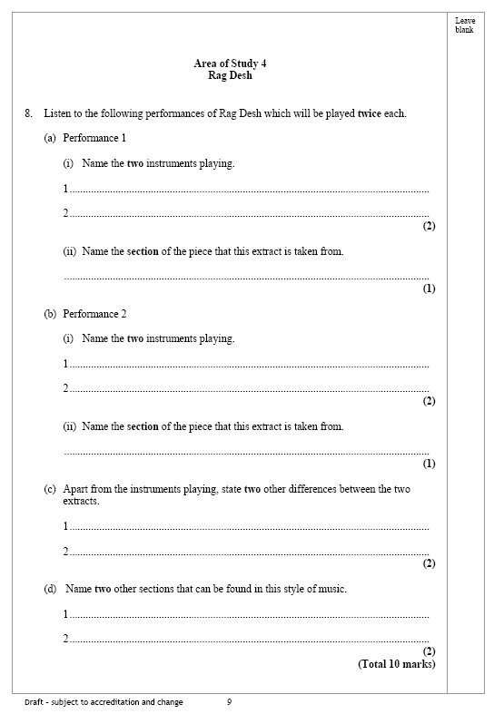

Here is an example of the examiners answer sheet.
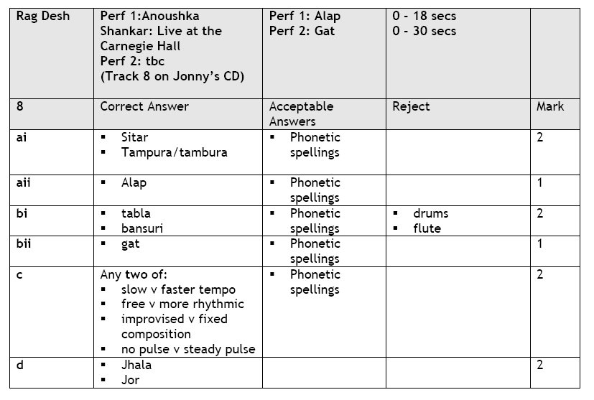
How many did you get right? ________________________________________________

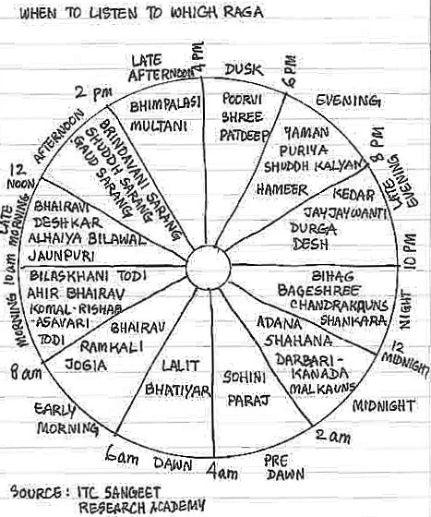

AoS 4
Rag Desh

Terms | Definitions
Raga
Tala
Rag desh
Alap
Jor
Jhalla
Gat
Bols
Sam
Teental
Meend
Tan
Bansuri
Shehnai
Swarmandal
Esraj
Tambura
Tabla
Sitar
Sarangi
Sarod
Pakhawaj
Bhajan
Drone
Tihai

