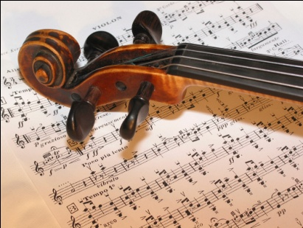
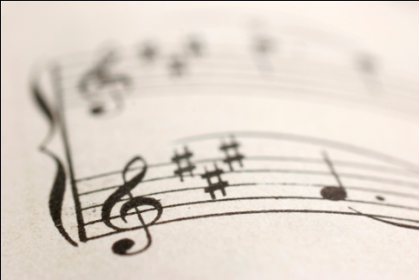
AOS 3
Popular Music in
Context

Set Work 9

Moby:
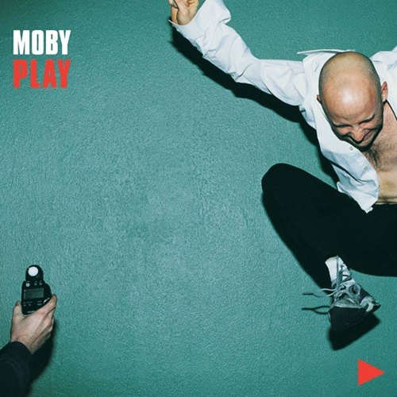
Why Does My Heart (Feel so Bad)

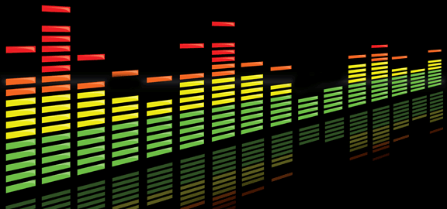
Development of Club Dance
- For the purposes of GCSE Music, the term 'club' dance music is used to refer to dance music that would normally be played in nightclubs by DJs
- In normal conversation we would simply refer to it as dance music and und erstand it to be club dance.
- Dance music has many different genres and sub-genres, each of which has its own set of influences and developed on its own unique musical path.
- On the whole, modern dance music can be traced back to the fusion of toasting (where a DJ would talk rhythmically over the music, interacting with the existing song lyrics often in a boastful and rather rude way, so as to hype up the audience) and dub from Jamaica with early hip-hop beats, electro from Europe and disco.
Dub
- The art of taking an original song and 'remixing' it.
- Bob Marley's producer, King Tubby, took some reggae tracks, removed the vocal part and overdubbed some effects (hence 'dub') on the instrumental tracks.
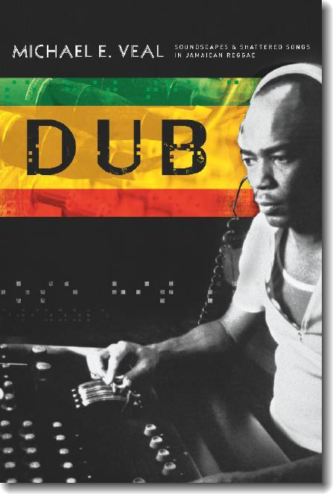
- The style developed in the early 1970s when King Tubby and Lee Perry (amongst others) turned it into a marketing ploy; they would record the instrumentalists and vocalists in one session and release the song as a single, but on the B-side they would put a dub remix of the track, displaying their own creativity as well as saving money on recording costs.
- These dub artists can be considered as the first DJs; they were employed in the mid-1950s (before dub was developed) to use their 'Sound Systems' to play music through.
- These were basically PA systems through which they were able to amplify their music. They became popular because they were cheaper to hire than a band of musicians.
- They would often sign artists to record exclusively for them so that they had an edge in the market by playing exclusive tracks on their Sound Systems.
Scratching
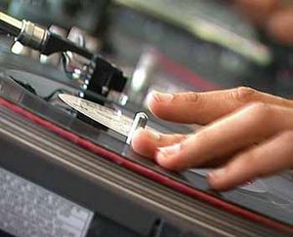
- In 1975, DJ Grand Wizard Theodore is said to have discovered 'scratching' - a technique where the record is spun by hand, creating a scratching sound.
- This technique was developed to such an extent that DJs would use the record deck as an instrument, improvising over their beats.
- The earliest examples of rap music took place in outdoor parties where DJs would play their beats, demonstrating their scratching skills and toasting/MCing over the top.
- The Sugarhill Gang (named after the label that got them together) released the first recognised rap single called 'Rapper's Delight' in 1979.
- It was a rather sanitised version of the street music, suitable for public release.
Chicago House
- In Chicago, in the mid-1980s, DJs such as Frankie Knuckles and Farley 'Jackmaster' Funk pioneered a sound that was to become known as house (named after the club where it was first played - The Warehouse).
- The DJs would take existing tracks and remix them, or cut them up, mixing them together with other tracks because they did not have enough new material to play.
- Frankie Knuckles is sometimes known as 'the godfather of house' because he was the first to bring some of these ideas to the Chicago clubs.
- Music played in The Warehouse ranged from disco and soul through to Euro synth-based pop.
- Sometimes the DJs would bring in a drum machine to exaggerate the four-to-the-floor bass drum beat that was characteristic of house music.
Garage
- While the popularity of Chicago house music was gradually dying down, another scene was starting in New York.
- In a club called the Paradise Garage, DJ Larry Levan pioneered a style that was much more melodic than house, taking its influences more from soul and R'n'B.
- This style again took its name from the club where it was first played, becoming known as garage.
- In the UK, the Ministry of Sound, based in London, was heavily influenced by the garage sound.
- By this stage, Moby was based in New York and was gradually becoming more and more involved in the hip-hop/dance music scene.
Summary of Club Dance
Style | Dates | Features | Other information

Background To Moby
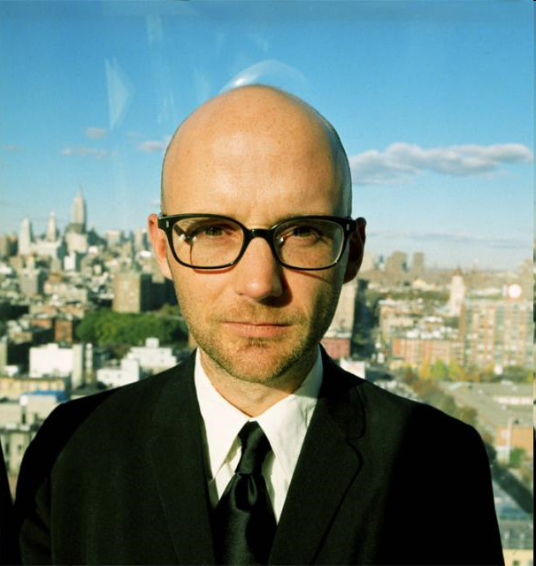
- Moby was born Richard Melville Hall in 1965 in New York.
- He was brought up in Connecticut, taking classical guitar lessons at school from the age of 9.
- From 1980 to 1985 he played guitar in a number of punk-style bands including The Vatican Commandoes, Flipper and AWOL. The Vatican Commandoes released an EP in 1983 called 'Hit Squad for God'.
- Moby attended the University of Connecticut, but dropped out in 1985 to pursue his music career that consisted of DJing at The Beat club in New York and gigging/recording with his band at the time, AWOL.
- In 1989, after years of trying, he got his first recording contract (with Instinct Records).
- In 1990 he released his first single called 'Mobility' with limited commercial interest, but his 1991 single 'Go' was the track that gave him his big break, bringing him to worldwide notice.
- 'Go' makes use of a sample taken from the cult TV series Twin Peaks, making it instantly recognisable to millions of listeners. It charted in the top 10 in the UK, giving Moby his first appearance on Top of the Pops. This, along with his DJing work, brought him recognition from established acts such as The Prodigy and Orbital, whose work he remixed.
- In the early 1990s he released a number of other singles and built up his reputation touring with artists from a range of musical backgrounds including The Prodigy, Orbital and the Red Hot Chili Peppers.
- In the sleeve notes for his albums, Moby writes about causes that he feels passionately about.
- He feels very strongly about human and animal rights, specifically believing that we should do everything we can to alleviate suffering of any kind, whether of humans or of animals.
- As such, his beliefs have led him to become a vegan, where he avoids the eating, wearing or use of any animal products.
- He is outspoken about his Christian beliefs, although he is opposed to many of the policies of the Christian right wing in America, holding much more liberal views.
- He is very happy to write and speak about his beliefs and faith, but does not feel that he should force his opinion on anyone else, believing that each informed adult should make their own choice in everything that they do.
Background to Play
- In his music, Moby covers a wide range of styles. His first official album release, Everything is Wrong (1995), is definitely within the dance genre, but is hard to classify where exactly it fits within this.
- He immediately followed up this album with a hardcore industrial album called Animal Rights, playing as part of a rock band.
- However, Animal Rights did not do terribly well commercially, so he returned to the dance genre with his 1999 album, Play.
- When Moby works on an album or song, he takes a very long time over it, coming up with the initial idea quite quickly, but spending a long timetweaking and fine-tuning every detail.
- Because he generally works on his own, he is keen to take time out from his work after he has come up with a mix, revisiting it some time later to make a more objective judgement about the quality of the work.
- He records at home in his own recording studio
- Moby spent the majority of 1998 working on the tracks for Play, releasing three singles from the album in 1999, which received little public attention in the UK, but his fourth single from the album, 'Why Does My Heart Feel So Bad?', reached number 16 in the UK charts and was received with critical acclaim.
- The style of the album is described as ‘techno dance music’. However this track is better described as ‘downtempo’ – a more relaxed style often used in chill-out rooms.

Moby: Why Does My Heart Feel So Bad? (1999)

This piece is made up of three simple chord progressions, each of which lasts for eight bars:

Section A  Male singer | Am | Am | Em | Em | G | G | D | D

Section Bx  Female singer | C | C | Am | Am | C | C | Am | Am

Section By  Female singer | F | F | C | C | F | F | C | C

Below is the overall structure, when you feel confident, play along to the track.
A1 | A2 | A3 | A4 | A5 | Bx1 | By1 | A6 | A7 | One bar pause | Bx2 | By2 | By3 | A8
Intro |  | Verse |  |  | Chorus |  | Verse |  | Break | Chorus |  |  | Outro

SAMPLES AND MELODY
- Moby makes extensive use of vocal samples in his songwriting - he says, 'I sample vocals because, try as I might, I cannot sound like a black woman from 1945. I'm a skinny white guy! If I want to have African-American vocals, I either have to bring a woman in to sing them or I need to find vocal samples' (interview in Sound on Sound, February 2000).
- 'Why Does My Heart Feel So Bad?' is built around two vocal samples taken from a recording of a gospel choir made in 1953.
- Both vocal phrases are in the key of A minor, but Moby has chosen to harmonise one with a sequence that makes it feel minor and the other with a sequence that makes it feel major.
- Part of Moby's style is to find new ways of harmonising samples. He may use a similar harmony to that of the original, but he may also find a new and interesting way to harmonise it, entirely depending on what he finds most pleasing to listen to!
- The song is based on two samples taken from a recording made in 1953 of a gospel choir singing King Jesus Will Roll All Burdens Away.
- Moby manipulates the sample to completely reverse the meanings of the words, for example he changes the original word ‘glad to ‘bad’ so that the lyrics become an expression of hurt rather than happiness.
- He then loops these to create a melody that is simple and repetitive. Notice that the samples have an authentic ‘vintage’ quality because Moby doesn’t remove the surface noise found on gramophone records of that period. Although his music is electronically based he is keen not to make it sound sterile.

STRUCTURE AND TEXTURE

As discussed earlier the song is based on a verse-chorus structure with looped samples to create both the verses and the choruses. There is one bar in the piece were everything stops for one bar – this is called a breakdown.

The texture is built up as individual tracks introduced one by one:

Theme | Description
A1 | Intro piano only, no clear sense of pulse
A2 | Sampled male voice  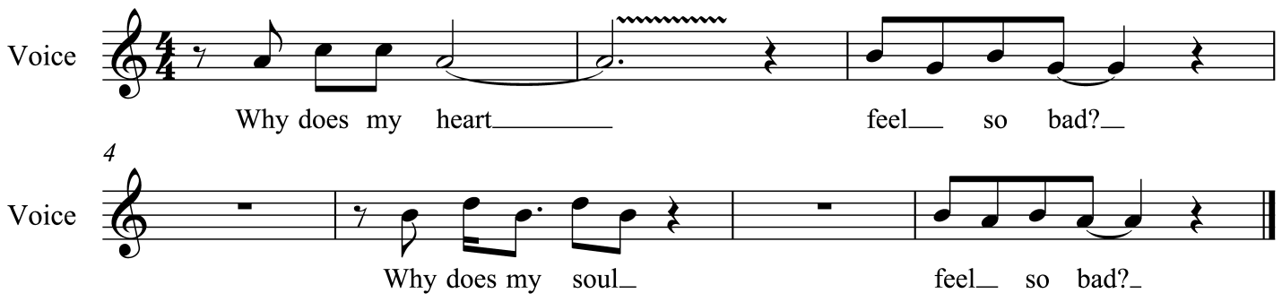
A3 | The addition of drums and other percussion makes the beat clear. Call & Response between vocal sample, string synthesiser & right hand of piano.  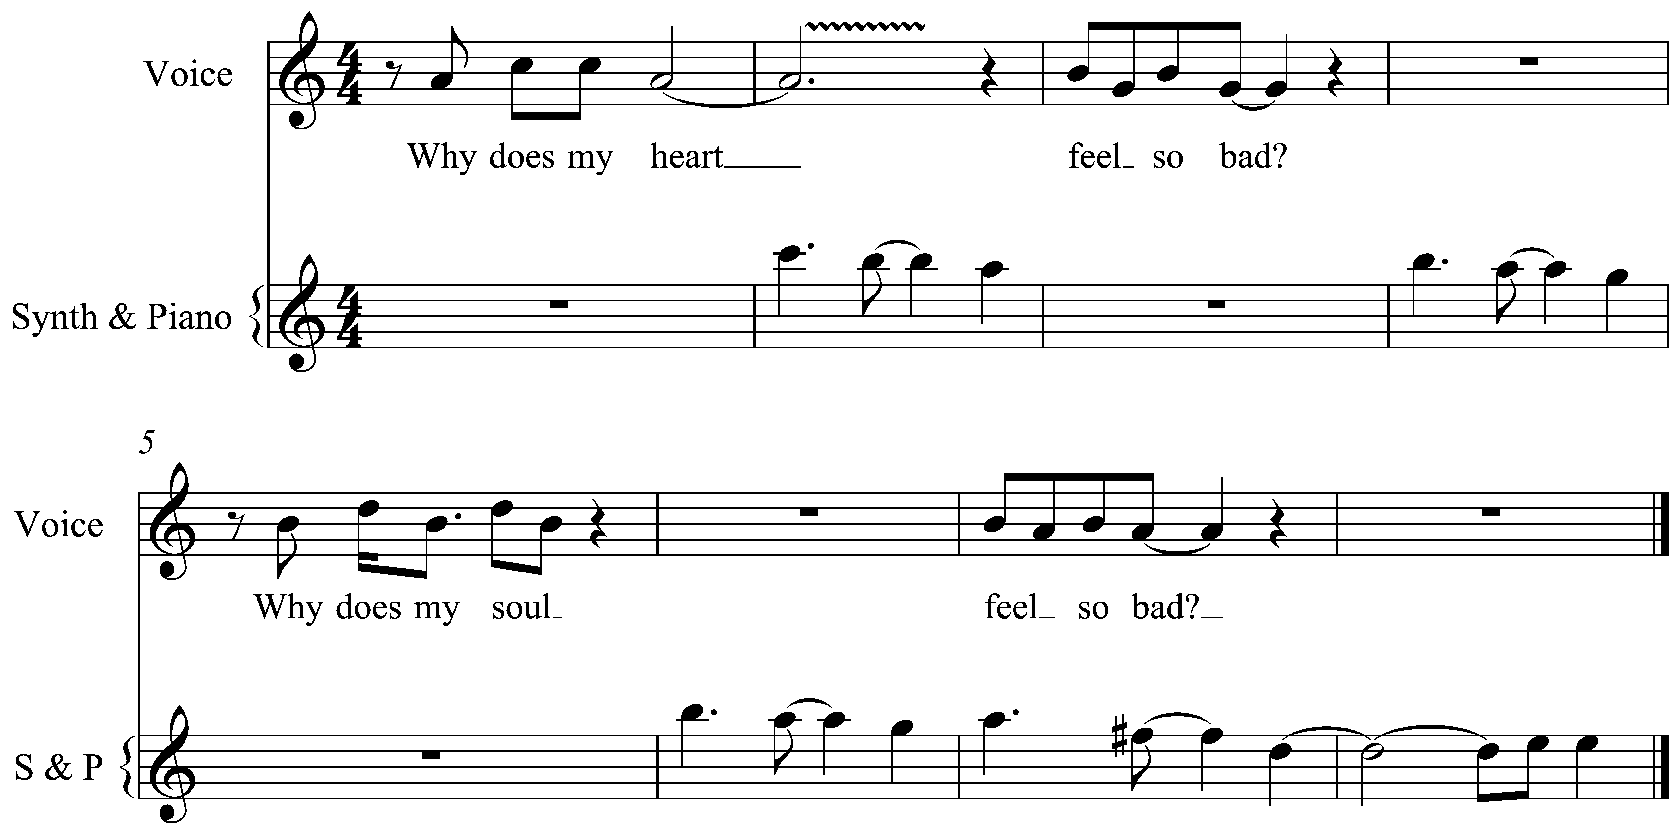
A4 | Bass and string synthesiser  See score – p.94
A5 | Syncopated piano chords  See score – p.94
Bx1 | Sampled female voice  See score - B1
By1 | New chord sequence. Sample is sometimes re-triggered to provide an echo effect that sounds like a canon.
A6 | Male singer and second vocal line - EQ effect added – high-pass filter – sounding like listening to a voice on the telephone because the only frequencies allowed to pass through are the high frequencies
A7 | A6 repeated - one bar pause with fading echoes
Bx2 | Female singer, no piano or percussion
By2 | Piano and percussion return
By3 | By2 repeated
A8 | Male singer, no piano or percussion

RHYTHM, TEMPO AND METRE

The metre of this piece is _______________________ and has a steady tempo of 98bpm.

A key rhythmic feature in this piece is Moby’s use of syncopation as mentioned earlier (A5). In order to create contrast he does vary the rhythms between the sections, for example the piano pattern changes at the end of the first verse and static chords appear in the second chorus.

The drum loop is made up of a breakbeat (a drum solo) that Moby sampled from a hip-hop track.
Indicate in the table using crosses which beat the bass and snare drum play on:

Beat | 1 | 2 | 3 | 4
Snare drum

Bass drum

USE OF TECHNOLOGY

List below the four pieces of equipment that Moby used to produce this track:

Equipment | What it does.....
Synthesiser
Sampler
Drum Machine
Sequencer
Effects Units

The use of effects is an important tool in electronic music; Moby uses a number of subtle effects within this piece. He feels that it’s more important for the music to trigger an emotional response in the listener than for it to be pristine and clinical. This is why for example his vocal samples still have the background noises intact. Within the mixing stage Moby panning;

Listen to the opening eight bars of the piano intro through headphones to hear how Moby has created a sense of movement from left to right.

Equipment | Purpose
Yamaha SPX990 Multi-effects unit | To apply reverb and delay to tracks
Roland TR909 drum machine | Sound source for drum loops
Emu Proformance piano sound module | Piano sound source (there are two piano sounds on the track, one from an old Yamaha synth and another from the Emu)
Roland Juno 106 | Synth bass sounds
Yamaha SY22 and SY85 synthesisers | String/synth pad sounds
Akai S3200 sampler | Sampling the vocal sounds off the original record and any subsequent editing
Important points to note
- Moby feels that it is more important for music to trigger an emotional response in the listener than for it to be pristine and clinically well produced.
- This is why he has left the vocal samples with all the background noise intact. He experimented with removing much of the noise with powerful digital editing tools, but found that this removed some of the emotional content that he particularly liked, so decided to use the unedited version instead.
- This adds extra texture to the piece - the point where the sample cuts off is very sudden and percussive in its effect, so the background noise acts almost as another percussion instrument.
- The use of effects is an important development tool in electronic music, on the same level as traditional development techniques such as melodic and rhythmic development.
- Listen particularly to the difference in the use of reverb and delay on vocal sample 2 when the section changes at 3:18. Moby uses other subtle effects editing throughout the song.
- In addition to the use of reverb and delay, much attention has been given to where the sounds all fit in the stereo field (where they have been placed in the left-hand and right-hand speakers) and the EQ applied to each sound.
- EQ is short for equalisation. It was originally used to even out the problems inherent in early recordings because the media used to record on was far from able to give an accurate reproduction of the original sound
- EQ allowed the recording to be more equal to the original sound source. Essentially it is a sophisticated tone control, allowing the relative volume of the treble, middle and bass frequencies to be adjusted independently of each other.
- On modern studio equipment, there is a very high level of control over the frequency of a recorded sound, allowing many EQ settings to be applied at the same time (e.g. the bass could be boosted while there is a slight dip in the low-middle frequencies, but also a slight boost for the very high frequencies).
- If you listen to the 'telephone voice' effect in verse 2, you can hear that the bass and higher treble frequencies have been almost completely removed, giving an effect similar to that of singing down a telephone.

HARMONY AND TONALITY

The harmony is diatonic throughout and is made up of three simple chord progressions seen earlier. The verses are in the Dorian mode on A (flattened 3rd and 7th) and the choruses are in C major.

Harmonies in dance music are generally very simple. Throughout this song, there are only six chords used.

Moby does not have an analytical approach to choosing harmonies - he does not think too much about what chords would be theoretically correct, he just chooses the chords that trigger the appropriate emotional response at any given moment.
This means that he probably did not think about the D major chord containing an F#, which makes the F chord sound so fresh when it occurs in the second half of the chorus, he just harmonised the melody in the second half of the chorus with an F chord, decided that it sounded good, and stuck with it.
Also use of the following chords
- Sus2 / Sus4 chord a triad with the major or minor third replaced by the second degree of the scale / fourth degree of the scale

Terms | Definitions
Sequencer
Sampler
EQ
Reverb
Delay
Sample
Manipulation
Breakdown
Panning
Loops
Dorian mode

