Area of Study 3 – Set Work 7

Miles Davis:

All Blues(1959)

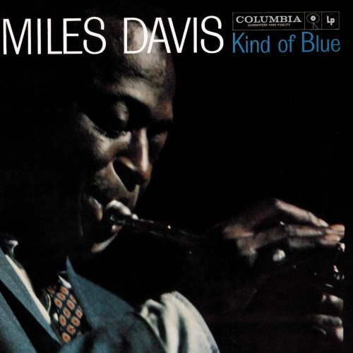

Slaves: their work and music in North America
The bulk of African slaves in America worked on large cotton and rice plantations. Although slavery was made illegal in 1808 it continued to exist in the southern states until president Abraham Lincoln came to power and sought to abolish it.
At the end of a civil war between the industrial northern states and the southern states where the plantations were, slavery was abolished in 1865.
In the ‘Deep South’ African slaves were forbidden to touch any musical instruments because their masters felt they might use them to communicate secret messages and cause rebellion. However some slaves made instruments such as the banjo. This was based on African stringed instruments.
The banjo has gone on to become an instrument that is played in many different musical contexts. It is widely used in country & western music but it was also used in the early days of jazz.

From Negro spirituals to gospel

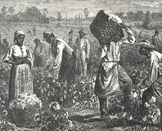
Slaves from the same ethnic groups would always be split up because the plantation owners feared that they might plot a rebellion if they could communicate with each other. Ashanti, Yoruba and Wolof were all scattered around the work forces so that there was no common language.
However, the slaves did manage to create a language they could all understand and they made songs together. They did this to keep their spirits up when they were doing hard manual labour such as picking cotton. A lead singer would sing a line and then a chorus would answer: call and response.
The songs that they sang together as they worked in the plantations were called ‘field hollers’ or ‘work songs’. They became an important part of African-American culture and there was a specific way of singing that came with them.
The ‘Call and response’ singing heard on the plantations would eventually make its way into the first black churches in America. The first black church songs were called Negro Spirituals. later evolving into gospel.

From Gospel to Blues
There is a great divide between gospel and blues. Gospel was music from the church; the blues was music from outside. Although these two genres were bound by the same important technique of call and response they had vastly different lyrics; gospel praised the lord whereas the blues spoke of heartache and real life. Some blues songs are rude, suggestive and funny. Some are very sad.
One of the greatest blues singers of all time was Bessie Smith and she brought a larger than life character to songs in which she often spoke of her suffering at the hands of men.
Many classic blues songs are sung by a musician who accompanies himself on guitar over a verse that lasts 12 bars. This is called the 12 bar blues.

Bar 1 | Bar 2 | Bar 3 | Bar 4
Chord I | Chord I | Chord I | Chord I
Bar 5 | Bar 6 | Bar 7 | Bar 8
Chord IV | Chord IV | Chord I | Chord I
Bar 9 | Bar 10 | Bar 11 | Bar 12
Chord V | Chord IV | Chord I | Chord I / V
By the early twentieth century black Americans started playing the blues in bars and clubs beyond the southern states. Features of this style of music included the use of blue notes and syncopated rhythms.

From Blues to Jazz
Although jazz originated in America, and most of its famous players are American, it has actually been created and played all over the world since as early as the 1910s. Almost as soon as it was being played by African Americans in the streets of New Orleans, jazz was also arriving in countries as far flung as Britain, Japan, Australia, and South Africa. Sometimes African Americans brought the music with them when they travelled (often trying to escape the racism of America to find more tolerant places to settle). Jazz also arrived through recordings carried by travellers, and the music and its accompanying lifestyle were reported on in newspapers.
Jazz’s lively syncopated beats and improvised style caught the imagination of people all over the world, but each time it was seen as representing something different. Each time, it was also reinterpreted and changed with local accents – often mixed with the local musical styles. As a result, there are now many different kinds of jazz, over the page you will find a list of some of the various styles.

Decade | Jazz Style | Other Styles influenced by Blues | Technological Developments
1850 |  |  | Affordable pianos and cheap printed music led to a demand for new songs to be performed at home
1900 | Ragtime |  | Gramophone record player became popular with the invention of the 78rpm record, holds up to 3 minutes worth of music
1920 |  |  | Start of public radio broadcasting  and sound movies
1930 | Swing  Big Band Jazz
1940 | Be-Bop |  | LP record invented – 33rpm – holds up to 60 minutes worth of music  Singles invented – 45rpm – holds one song either side
1950 | Cool Jazz  Modal Jazz | Rhythm and Blues  Rock and Roll
1960 |  | Soul

Blues notes are notes which do not live in the normal triad chord, they are chromatic additions. There are 3 main Blues Notes:
- The flattened 3rd, which usually moves quickly up a semitone to the major 3rd
- The flattened 5th, which also usually moves up a semitone to the perfect 5th, or down a semitone to the perfect 4th
- The flattened 7th, which generally doesn’t move anywhere, it just sounds cool all by itself!
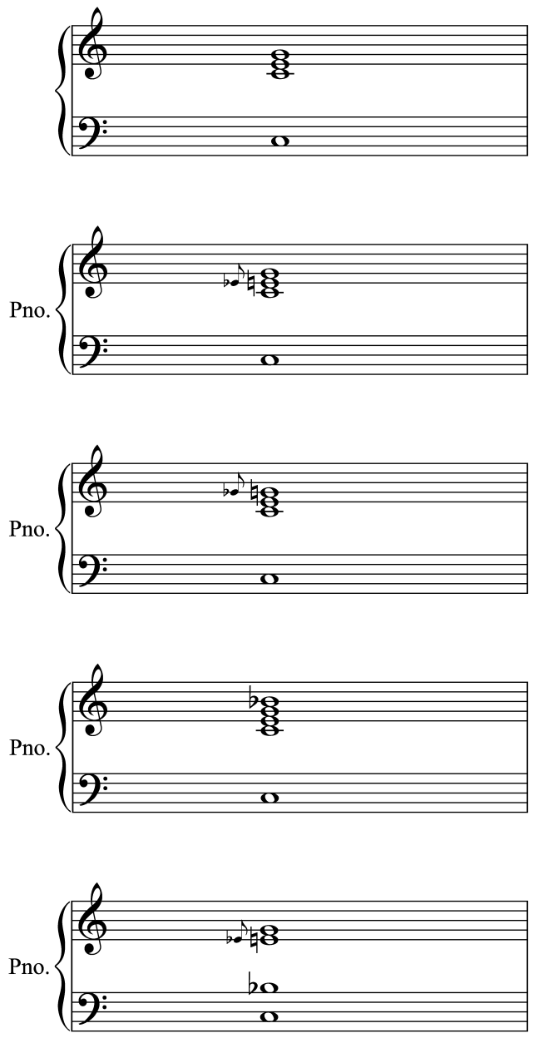
This chord has an added flattened 7th (a whole tone below the root)
This chord has a flattened 3rd Blues Note, which moves up to the normal 3rd
Here’s a normal C Major Chord
This chord has an added flattened 7th (in the LH) and a flattened 3rd to sound like a proper Blues chord
This chord has a flattened 5th Blues Note, which moves up to the normal 5th

Miles Davis 1926-1991

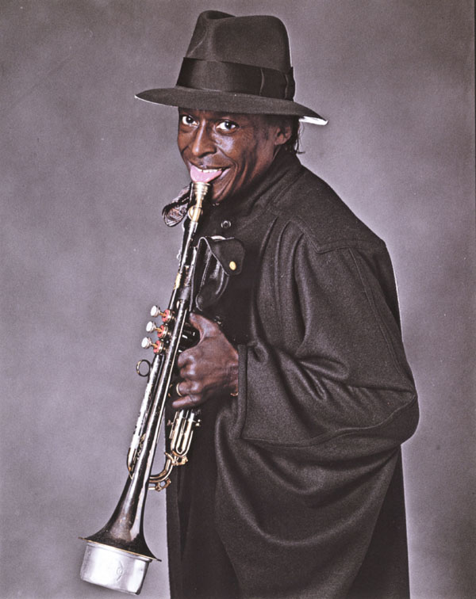
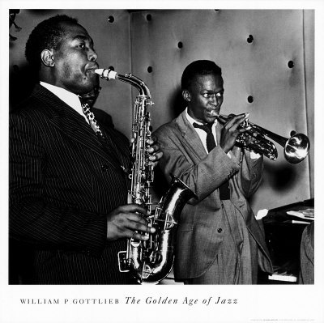
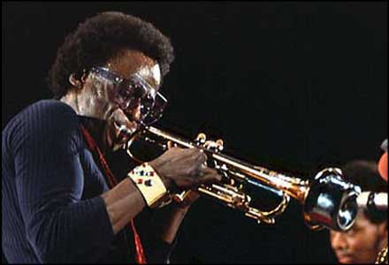

The legacy of Miles Davis is an unprecedented journey of music, creativity, innovation and personal charisma. His career spanned nearly five decades and he had a huge influence on how we think about jazz and the jazz trumpet. Miles Davis was responsible for, or contributed heavily to five major styles in jazz from the 1940s to the 1970s:
- bebop (1940s),
- cool jazz (1950s)
- modal jazz (1950-60s)
- hard bop (1960s)
- fusion (1970s)

All Blues
Despite its name All Blues is not an example of Blues. However list 4 reasons below why this name may have been used
1.
2.
3.
4.
All Blues is an example of _________________ because __________________ _____________________________________________________________ and uses the following features of Jazz _______________________________ _____________________________________________________________
All Blues was performed and recorded in one take with no rehearsal time. What would the performers need to know before beginning take so that the performance is successful?
________________________________________________________________________________________________________________________________________________________________________________________________________________________________________________________
STRUCTURE

In total All Blues plays the 12 Bar Blues pattern 19 times with a four bar riff in between each main section. One statement of the 12 bar blues chord progression is called a chorus. The main pre-written melody is called the Head, solo choruses are improvised over the same 12 Bar Blues chord sequence.

List the instruments you can hear below in the correct order:
Section | Instruments
Intro
Head 1 x 2
Solos x 4
Solo 1 – 4 choruses

Solo 2 – 4 choruses

Solo 3 – 4 choruses

Solo 4 – 2 choruses
Head 2 x 2

Outro/Coda

HARMONY AND TONALITY

Earlier we mentioned that this piece is based on the 12 bar blues chord progression. In the next diagram we can compare the blues progression we saw earlier with the one used in this piece:
12 BAR BLUES IN G All blues
Bar 1 | Bar 2 | Bar 3 | Bar 4
G | G | G | G
Bar 5 | Bar 6 | Bar 7 | Bar 8
C | C | G | G
Bar 9 | Bar 10 | Bar 11 | Bar 12
D | C | G | G/C
Bar 1 | Bar 2 | Bar 3 | Bar 4
G7 | G7 | G7 | G7
Bar 5 | Bar 6 | Bar 7 | Bar 8
Gm7 | Gm7 | G7 | G7
Bar 9 | Bar 10 | Bar 11 | Bar 12
D7 | Eb7/D7 | F / G | F / G6

All Blues uses EXTENDED CHORDS such as DOMINANT 7^{ths}, and the last line also uses ALTERED CHORDS. Altered chords are where you substitute a more interesting chord as opposed to the normal 12 bar blues chord.

A Dominant 7th is a normal triad with the 7th note above the bass added. The dominant 7th is ALWAYS a whole tone below the root note, so the dominant 7th of the chord of C is a Bb.

Adding a 7th, 9th or even an 11th to a triad turns it into an EXTENDED CHORD.
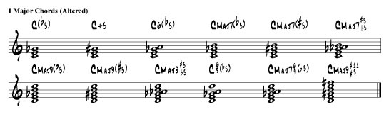
A #9 chord works on the same idea; you add the 9th note above the root and sharpen it (this is the same as adding a sharpened 2nd).
Bill Evans keeps the piano part interesting while COMPING (accompanying) by constantly changing the CHORD VOICING. Changing the voicing means simply changing the order of notes in a chord, in classical music this is known as inversions:
Changing which notes are at the top, bottom or middle, and how far they spread over the piano can dramatically change the way a chord sounds.

Task: Work out what the chords for All Blues are, write them below

Try playing the All Blues 12 bar blues chord progression with different chord voicings.
MELODY
The head melody is characterised by rising 6ths from D to B, and continues with simple stepwise (conjunct) movement. This is an example of Cool Jazz which is quite unlike the fast and high trumpet lines heard in Miles Davis’ bebop of the 1940s.

The accompanying riff includes the saxes playing a swaying figure in parallel thirds. It moves stepwise in a very narrow range.
Describe the technical term for the bass part: _____________________________________

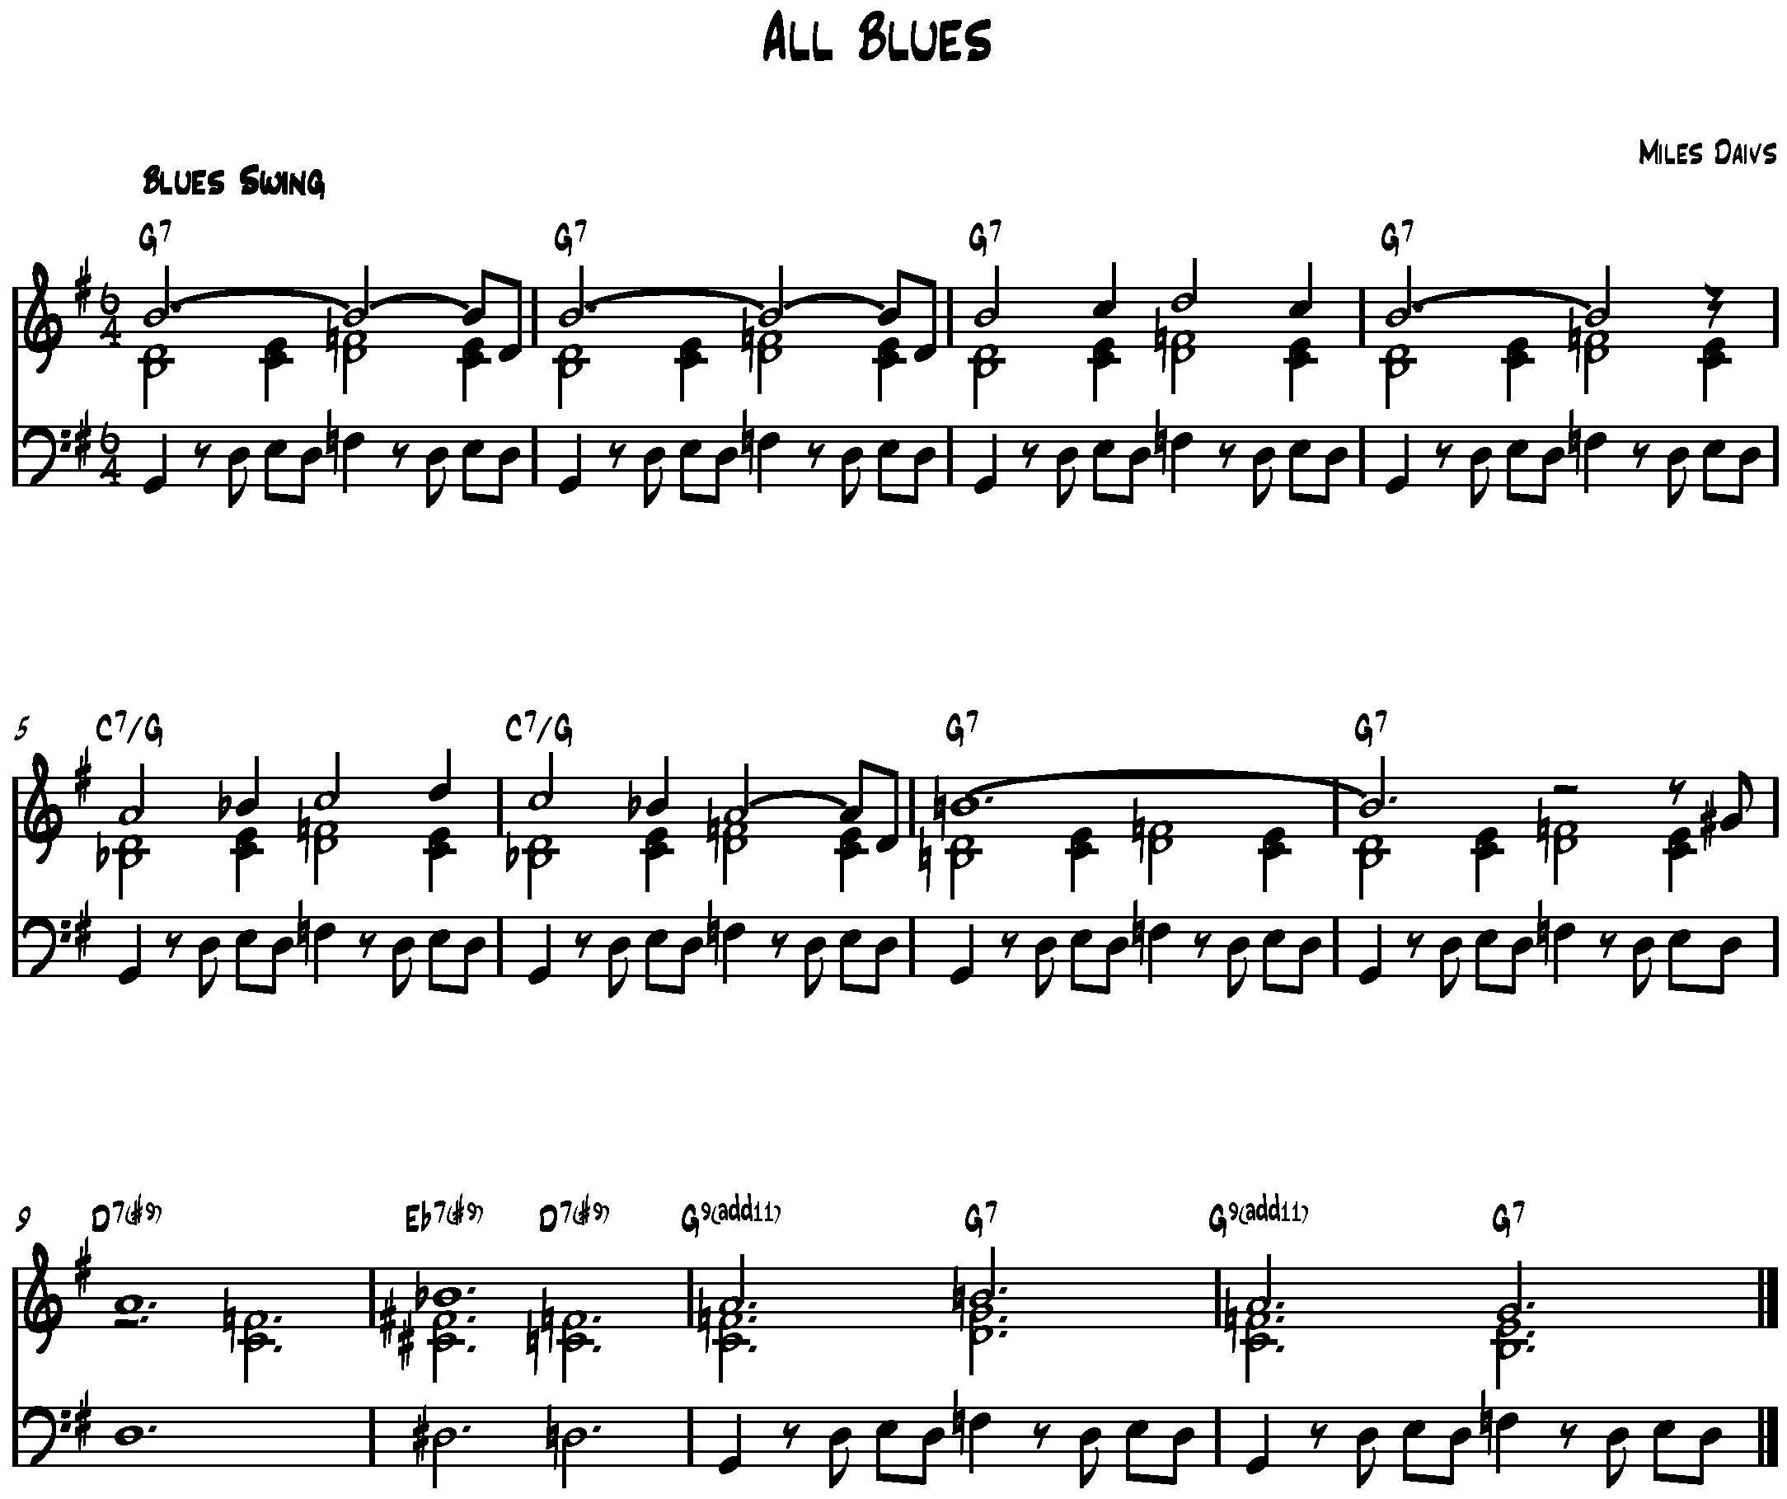
Circle and label the rising 6^{ths} in the melody and the parallel thirds/chords in the accompanying riff:

INSTRUMENTATION

Name the instruments and the players in the rhythm section in this piece:
______________________________________________________________
____________________________________________________________________________________________________________________________
______________________________________________________________

Name the instruments and the players in the frontline:
____________________________________________________________________________________________________________________________
__________________________________________________________________________________________________________________________________________________________________________________________
RHYTHM, METRE AND TEMPO

The time signature for All Blues is _______________________________

As is typical with jazz music the quavers are swung. This means that each pair of quavers is played with the first a little longer than the second thus creating a triplet feel. There is also frequent use of syncopation.

INSTRUMENTAL TECHNIQUES

Technique | Description | Bar
Pizzicato

Muted

Tremolo

Comping

Wire brushes

AoS 3
Miles Davis: All Blues

Terms | Definitions
Ragtime
Swing
Bebop
Cool Jazz
Blue note
Changes
Head
Frontline
Comping
Chromatic
Turnaround
Riff
Parallel thirds
Harmon mute
Improvisation

