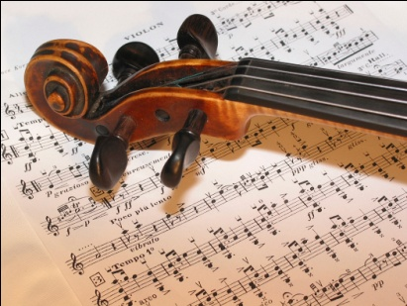
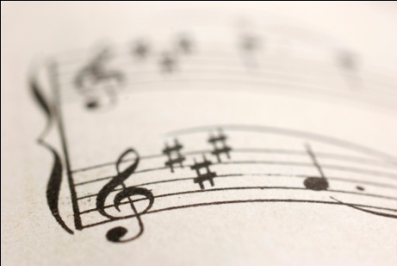
AOS 1
The History of Western Classical Music
1600-1899

Set Work 3

Chopin:
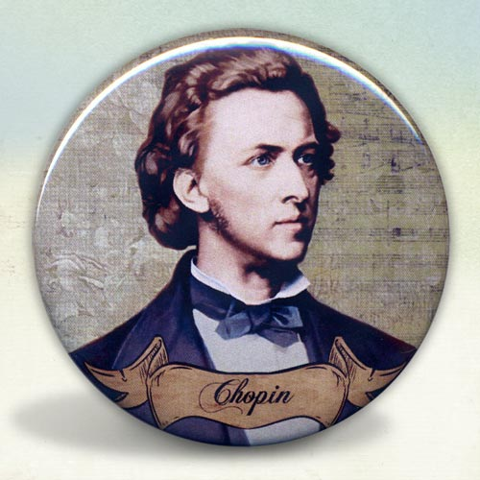
Prelude No. 15 in Db major

The ‘Raindrop’ prelude

Romantic Music
1825 - 1900

The age of Romanticism. Music influenced by other Art forms that dealt with expressions of intense human emotion – of emotions .love, grief, joy, death. Composers strove to write for expressive music responding to a wide range of emotions.

KEY FEATURES

- Large Orchestras (including the full range of instruments we now know)
- Greater freedom in form and design
- Structures become longer
- Melody lines became longer and more developed
- Music is more expressive and emotional
- Extended vocabulary of chords e.g. 7ths. 9ths and 13ths, Diminished 7ths,l dominant 13th, augmented 6th, Neapolitan 6th
- Harmony often chromatic and discordant – to portray emotion etc
- Increasing technical difficulty in some music leading to the rise of the virtuoso
- Strong and varied Dynamics
- Programme Music – Music which tells a story
- Expansion of the Piano

Romantic Orchestra
Significant expansion of the orchestra including Piccolo, Cor Anglais, Trombone, Tuba, Double bass

Listen out for,
- Larger orchestral sounds
- Expressive and emotional melodies
- More advanced harmonies – chromatic with striking dischords
- Symphonic poems / programme music
- Music including folk tunes – Nationalism

Famous composers
Chopin
Beethoven
Berlioz
Tchaikovsky
In order to gain a better understanding of this period of Romanticism it is useful to visualise the movement through architecture, art and literature.

A castle built purely on Romantic fantasy in the late 19th century

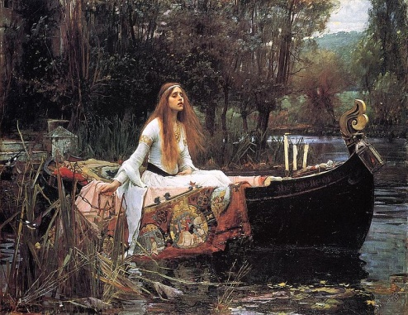

John William Waterhouse, 1888, The Lady of Shalott,
In terms of literature, the Grimm brothers were are among the best-known story tellers of European folk tales, and their work popularized such stories as Cinderella, The Frog Prince, Hansel and Gretel, Rapunzel, Rumpelstiltskin, Sleeping Beauty and Snow White. Here is an example of one of their stories written in the Romantic period.

THE OLD MAN AND HIS GRANDSON – The Grimm brothers
There was once a very old man, whose eyes had become dim, his ears dull of hearing, his knees trembled, and when he sat at table he could hardly hold the spoon, and spilt the broth upon the table-cloth or let it run out of his mouth. His son and his son’s wife were disgusted at this, so the old grandfather at last had to sit in the corner behind the stove, and they gave him his food in an earthenware bowl, and not even enough of it. And he used to look towards the table with his eyes full of tears. Once, too, his trembling hands could not hold the bowl, and it fell to the ground and broke. The young wife scolded him, but he said nothing and only sighed. Then they brought him a wooden bowl for a few half-pence, out of which he had to eat.
They were once sitting thus when the little grandson of four years old began to gather together some bits of wood upon the ground. ‘What are you doing there?’ asked the father. ‘I am making a little trough,’ answered the child, ‘for father and mother to eat out of when I am big.’
The man and his wife looked at each other for a while, and presently began to cry. Then they took the old grandfather to the table, and henceforth always let him eat with them, and likewise said nothing if he did spill a little of anything.

HOMEWORK
Research historical events which happened during the 19th Century and therefore influenced composers, the following youtube clips may help.

http://www.youtube.com/watch?v=XV_q45Otdic&feature=related

http://www.youtube.com/watch?v=oJnTTlgjVso

Using the knowledge that you have gained listen to Chopin’s Prelude No. 15 and give three reasons as to why this is a composition from the Romantic period.
________________________________________________________________________________________________________________________________________________________________________________________________________________________________________________________________________________________________________________________________________________________________________________________________________________________________________________________________________________________________________________________________________________

This prelude was given the nickname Raindrop why do you think this is?
______________________________________________________________________________________________________________________________________________________________________________________________________________________________________________________________________________________________________________________________________________________________________________________________________________________________________________________________________________

PRACTICAL TASK

- Using a keyboard and a key of your choice make up a short passage of music describing rain
- Try using scalic movement and short repeated patterns
- Decide whether you want a short jumpy (STACCATO) sound or smooth gentle rain like Chopin’s (LEGATO)
- Start and finish in your main key area
- Perform to the class
Chopin – 1810-1849

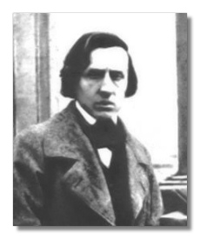

- Born in Poland
- Composed nearly all of his music for piano
- Spent most of his career in Paris
- Was a piano teacher, composer and performer
- Performed ‘salons’: concerts given to small, select gatherings of people
- In 1838 he went to Majorca and ended up staying with his lover in a deserted monastery in a place called Valldemossa.

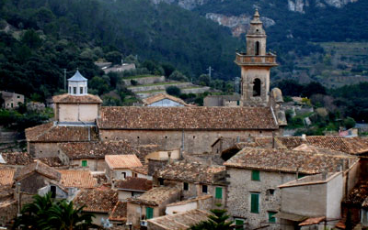

HOMEWORK

Chopin wrote 24 preludes, one in each of the 12 major and minor keys. Although the term prelude suggests an introduction to something else Chopin composed these as short, self contained movements. Bach however followed his preludes with a contrapuntal movement called a fugue. All of Chopin’s preludes were written for piano, with some more difficult than others. Create a power point presentation to the class about the history of the piano including a listening example of one of Chopin’s other preludes.

Chopin’s Prelude No.15 in D flat Major. Opus 28
AKA – ‘Raindrop’ – One of 24 preludes
Written in: 1838 – Romantic Era. Criticised for lack of structure and being so full of grief and anger.
Definition of Prelude: A brief opening of a piece that usually leads onto something else i.e. a fugue (a structure where parts enter at separate times or a piece of different parts – polyphonic texture) However, Chopin’s preludes are on their own – not followed by another piece. Each prelude depicts a different mood or emotion.

Stylistic features
- This piece is a perfect example of the Romantic era for expressing poetic feelings and emotions.
- Nature falls in to subjects favoured for musical expression by Romantic composers. Others are Love/Death/Tragedy/Natural world/Fantasy/Myths/Folklore/Legends
- Cantabile playing – legato and singing style
- Long melody lines with ornamentation
- Spreading arpeggios made possible by development of piano
- Broken chords accompaniment with pedalling effects
- Romantic Tempo rubato – flexible tempo for expression
- Varied dynamics with good control
Representations of rain

This prelude was written while Chopin was in Valldemossa, Majorca, during a rainstorm. This is represented by:
- Continuously repeating Ab’s in section A in the left hand – which is the dominant note of Db major. (dominant = 5th note of the scale)
- Continuously repeating G#’s in section B in the right hand– the dominant note of C# Minor.
N.B Both of these pedal notes represent the rain but do not destract the listener from the melody line.
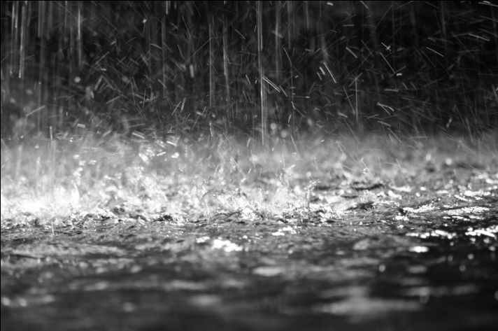

MELODY

Look at the main themes below and learn them.

Notice the repeating quavers in the third example. This can be found throughout section B. Chopin also uses this quaver pattern in section A thus creating a unifying feature.

The main theme is in the right hand and has a dotted rhythm which gives the melody a lighter feel than in section B. In the middle section the melody is in the left hand is made up of mostly crotchets and minims which help to create a darker more menacing mood.

STRUCTURE
Loose Ternary Form with a codetta.

N.b Notice the very unbalanced sections. Although over half the piece is the middle section, it is still remembered as the ‘Raindrop’ from section A! The repeat of A is a shortened version

 | Key | Main features | Bar numbers | Length of Section
A | Db Major | Lyrical melody accompanied by quavers in the bass.
B | C# minor | List three ways in which Chopin creates contrast in this section:
A | Db major | The opening repeated but shorter.
Coda | Db major | Melody is now in the middle of the texture, finishes on a perfect cadence.

How is the key of the middle section (C# minor) related to that of the tonic (Db Major)?
__________________________________________________________________

Differences between sections
Section A | Section B
- Db Major  - Lyrical right hand melody  - Light texture – melody with simple broken chord accompaniment  - Generally higher pitch  - Mostly piano throughout | - C# Minor  - Left hand melody  - Dense homophonic chordal texture  - Lower pitch generally  - Dynamic contrast, including Fortissimo

PERFORMANCE MARKINGS

Look at the following signs/abbreviations. List one place where you can find them in the score and write down what they mean:
 | Definition | Bar
Ped.

*

Sotto voce

Smorzando

Slentando

Acciacatura

Sostenuto

e

RHYTHM, METRE AND TEMPO

The time signature is called common time it is the same as _____________. This stays the same throughout the piece.

In bar 79 there is a dectuplet: ten notes of equal length fit into one single beat.
What is a septuplet? ______________________________________________________________________________________________________________________________________________________________________________________________________

Find an example of this within Chopin’s prelude: __________________________________________________________________

A key feature of solo music within the Romantic era is the use of rubato. This literally means ‘robbed time’; in essence it allows the performer to create a flexible tempo so that they can play expressively.

Key rhythmic features in the piece include the use of repeated quavers and dotted rhythms.

TONALITY AND HARMONY

Section | Key | Relationship | Final cadence
A

B

A

A dominant pedal can be heard throughout most of the piece. This is a ______ in section A and a _________ in section B.

TEXTURE
Largely homophonic – Melody and chords

Section | Texture | Further textural features
A | Homophonic | Melody in the RH  Broken chords in the LH
B | Homophonic | Melody in the LH  Pedal in the RH doubled in octaves  More chordal than Section A
A | Homophonic | Melody in the RH  Broken chords in the LH
Coda | Monophonic for 2 bars then homophonic | Melody in the middle of the texture  Sustained chords in the R and LH

DYNAMICS

In contrast to the first two set works Chopin uses a wide range of dynamics but there are no sudden changes. He uses lots of crescendos and diminuendos throughout. Notice that Section A is quieter than Section B, which climaxes to ff twice.

INSTRUMENTATION
Piano solo
Development of piano
- Reshaped and enlarged for better sound
- Range of notes increased top 7 octaves – greater pitch for musical expression
- Felt replaced leather on hammers – fuller tone
- Longer, stronger strings with increased tension
- Sustaining and soft pedals developed
Keyboard techniques used
- Cantabile legato – played legato (smoothly) in a singing style. Chopin was the founder of Cantabile playing
- Expressive use of pedals – made possible by the development of piano
- Rubato – player can be flexible with the tempo – allowing more expression
AoS 1
Chopin: Prelude No. 15 in Db ‘Raindrop’

Terms | Definitions
Pedal
Sostenuto
Sustain pedal
Legato
Cantabile
Acciaccatura
Rubato
Dectuplet
Ternary Form
Sotto voce
Smorzando
Slentando
Ternary Form
Prelude
Enharmonic
Modulation
Virtuoso performer
Imitation

Pivot note

