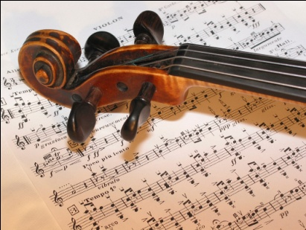
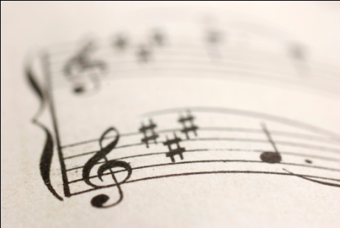
AOS 3
Popular Music in
Context
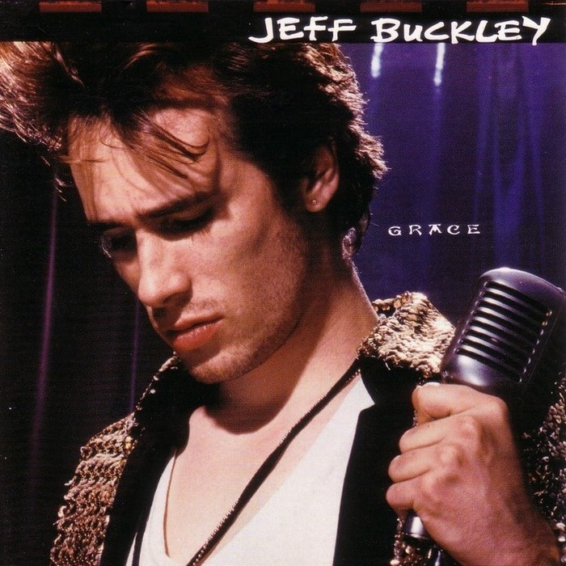
Set Work 8

Jeff Buckley:
Grace

Jeff Buckley 1966-1997
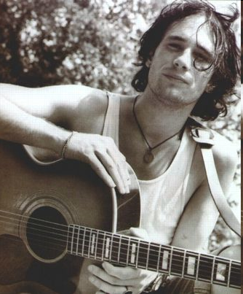
Jeff Buckley’s song Grace has several features that are commonly found in rock music such asfour beats in a bar, the use of verse and chorus form and the instrumental line-up.
- A singer-songwriter and guitarist born in California in 1966
- Both father and son possessed powerful voices with great emotional depth.
- He had an amazing range as a singer and often sang in falsetto
- Tim Buckley died of a heroin overdose at the age of 29
- Jeff Buckley died in a swimming accident at the age of 30
- The song 'Grace' is taken from the album with the same name
- Grace (1994) was the only studio album Jeff Buckley completed
- Jeff Buckley co-wrote the song 'Grace' with the guitarist Gary Lucas
- This piece is scored for two guitars, bass guitar, drums and synthesiser
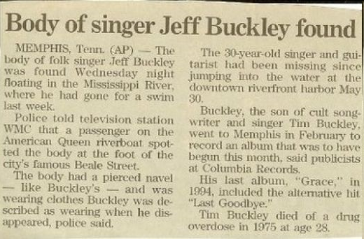

FOLK ROCK MUSIC

 | Key Features and Facts
1 | Refers to the traditional music of a country – the folk culture
2 | Often learned and performed by ear; songs are memorised and passed down through generations – oral tradition
3 | The lyrics described peoples’ views on politics and cultural issues, and were sung in a simple and direct style
4 | This led to a folk revival in the 1950s
5 | Artists such as Bob Dylan and The Byrds combined folk with pop and rock influences, creating the genre folk rock in the 1960s
6 | Jeff Buckley’s music is often described as folk rock though he was influenced by many genres. His one and only album Grace is very eclectic in style including Buckley’s own version of Leonard Cohen’s Hallelujah and Benjamin Britten’s setting of the Corpus Christi Carol.
7 | Although Buckley’s style is diverse much of his music retains the folk tradition of using song as a vehicle for story-telling.
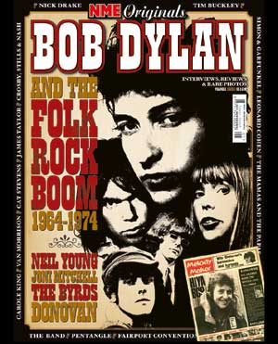

Jeff Buckley’s ‘Grace’
‘Grace’ comes from the album Grace which was released in August 1994, on the same day as Oasis’s ‘Definitely Maybe’, ‘Grace’ was Buckley’s only completed album. It is a rock ballad – a slow love song accompanied by a rock band. Buckley regarded this song to be about the way that true love can make it easier for people to accept their own mortality.
There's the moon asking to stay
Long enough for the clouds to fly me away
Though it's my time coming, I'm not afraid, afraid to die
My fading voice sings of love,
But she cries to the clicking of time,
Of time
Wait in the fire...
And she weeps on my arm
Walking to the bright lights in sorrow
Oh drink a bit of wine we both might go tomorrow, oh my love
And the rain is falling and I believe
My time has come
It reminds me of the pain I might leave
Leave behind
Wait in the fire...
It reminds me of the pain I might leave
leave behind...
And I feel them drown my name
So easy to know and forget with this kiss
But I'm not afraid to go but it goes so slow
Wait in the fire...
Some say that the lyrics seem to anticipate his own death by drowning!
Stylistic features
- Use of Power chords
- Emphasis on guitars
- Taking a fairly simple idea and changing it to make it interesting
- Typically Strophic in form – verse chorus structure
- Large use of guitar riffs
- Electronic effects used to enhance the sound
Unusual features for the time
- The time signature is 12/8, which means four dotted crotchet beats per bar. Most rock songs are in 4/4
- Unusual chord progressions. He chose chords that he liked the sound of
- Considering the song was supposed to be about love, the lyrics are quite morbid!
MELODY AND WORD-SETTING
The vocal part has an improvised quality and a very wide tessitura of over two octaves. Most of the vocal phrases are falling, reflecting the melancholy mood of the song. In the example below there are two examples of glissando, circle them and mark them clearly.

Opening of verse 1
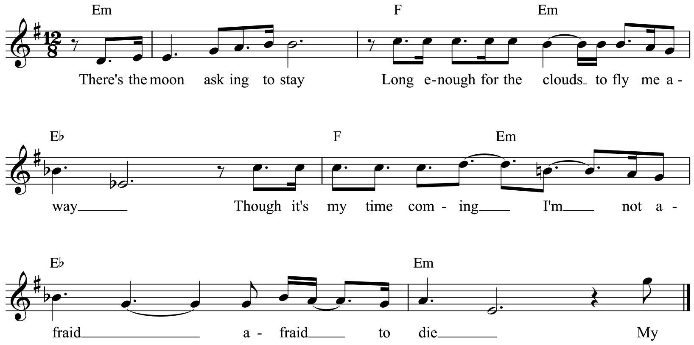

Most of the word setting is syllabic as you can see in the above example.
There are however some long melismas to emphasise certain words such as ‘love’ in the verse and ‘fire’ in the chorus:

Opening of chorus
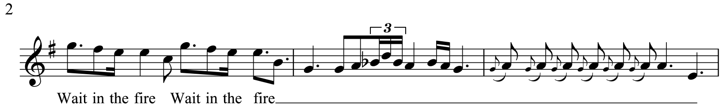

As mentioned earlier the lyrics reflect Buckley’s bleak outlook on love. There are many examples of word painting. Listen to the piece while following the score and indicate below how Buckley highlights these words in the music.

Word | Bar/Section | Musical Technique
Die | 13
Love | 15
Fire | 23
Leave | 58
In the bridge there is a passage of vocalisation – wordless singing – in which Buckley uses falsetto. What does this mean? _____________________________________________________________
STRUCTURE
Listen to the piece again but this time focus on the structure, it is in verse-chorus form. Complete the following structural chart:
Intro | Verse 1 |  | Intro
Bars 1-7 | 8-19
Instrumental | Vocal:  (‘There’s a Moon’)

 |  | Intro | Verse 3
Bars 44-
Voice  (‘Wait in the fire’) |  |  |  | Voice  (Improvisation)

INSTRUMENTATION AND TEXTURE
Homework:
The following words are all related to guitar and string playing, some of which are used in Grace. What do they mean?
Drop-D tuning
______________________________________________________________________
______________________________________________________________________
______________________________________________________________________
Flanger
______________________________________________________________________
______________________________________________________________________
______________________________________________________________________
Delay
______________________________________________________________________
______________________________________________________________________
______________________________________________________________________

Slide
______________________________________________________________________
______________________________________________________________________

Vibrato
______________________________________________________________________
______________________________________________________________________

Distortion
______________________________________________________________________
______________________________________________________________________
______________________________________________________________________

Power chords
______________________________________________________________________
______________________________________________________________________
______________________________________________________________________

Bending
______________________________________________________________________
______________________________________________________________________
______________________________________________________________________
Guitar ‘whisper’
______________________________________________________________________
______________________________________________________________________
______________________________________________________________________

Pizzicato
______________________________________________________________________

TECHNOLOGY/TEXTURE
To help create a thicker texture the guitar parts are overdubbed – this is the re- recording of the same guitar part and then mixed together. The extra vocal parts in the bridge section are also produced through overdubbing, this is also known as double tracking.
EQ is used throughout but is particularly obvious towards the end of this piece in the vocal parts. EQ is basically adjusting the tone controls so therefore boosting or cutting top, mid or bass frequencies. At the end of the piece the top frequencies are boosted in the vocal parts so that they are clearly heard above the backing.

TONALITY AND HARMONY
The song is in E minor, although the tonality is often ambiguous. Look at the first two bars of the introduction. Notice the use of accidentals alongside the key signature of E minor:
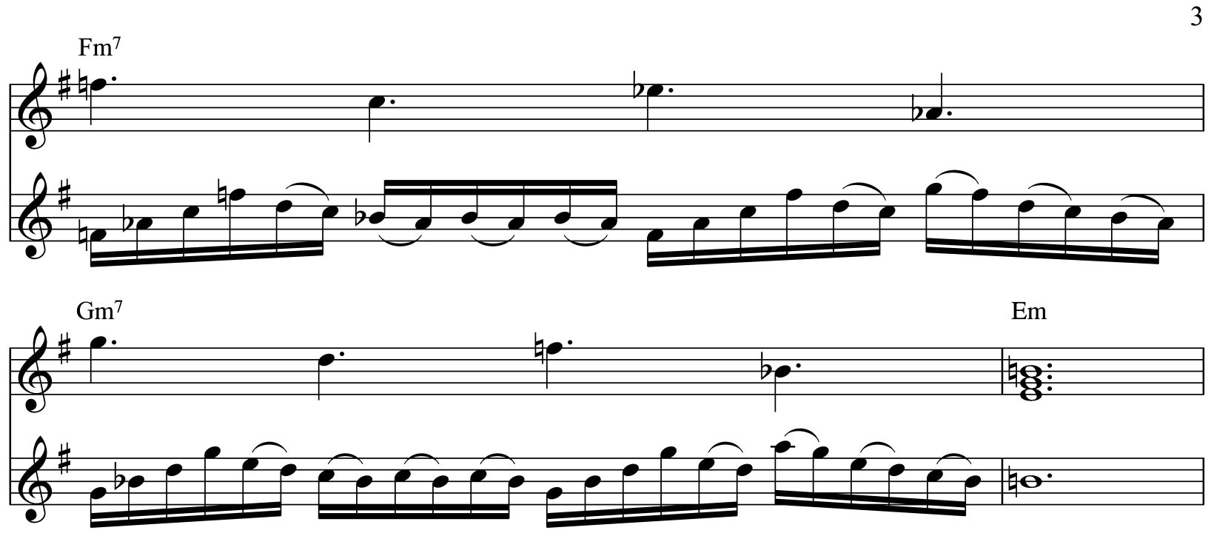

Although it is in E minor the song opens with two chords not normally found in this key (F minor7 and G minor7). Both chords have an added minor seventh. This gives the ambiguous feel to the tonality – it is hard to tell what key it is in. The standard I – IV – V chord progressions of rock music are avoided. Instead the chords are more chromatic and move in parallel motion.
Can you find other examples of parallel motion chords in the score?
____________________________________________________________________________________________________________________________________________________________________________________________________________________________________________________________________________________________________
By using chromatic chords the tonality is ambiguous. Dissonance is created by deliberately allowing open E strings on the guitar to sound against an F chord and an Eb chord in bar 20 and 21.
Main Chord Sequence
Although the chords for the verse and chorus look and sound complex, and crunchy at times, they are quite simple on the guitar. They use the same chord shape, that just moves up and down the guitar, keeping one or more open strings as a drone. The harmonies come from the ideas played on the guitar, not the other way round. The chords are power chords spread across three frets, played in different ways in each section, making it sound more interesting with different textures.
RHYTHM, METRE AND TEMPO
The metre is _________.
There is frequent use of both syncopation and cross rhythms throughout.
Indicate in the table using crosses which beat the bass and snare drum play on:
Beat | 1 | 2 | 3 | 4
Snare drum

Bass drum

This type of beat is known as a backbeat and is characterized by: __________________________________________________________________________________________________________________________________________________
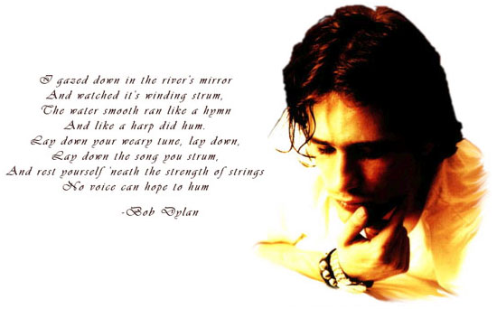

AoS 3
Jeff Buckley: Grace
Terms | Definitions
Ballad
Verse Chorus Form
Tab
‘Drop-D’ Tuning
Blue notes
Hammer-ons
Pull-offs
String bending
Slide guitar
Glissando
Melisma
Syllabic
Falsetto
Overdubs
Word painting
Tessitura
Distortion
Power chords
Guitar Whisper
Delay
Reverb
Double tracking
Multi-tracking
Flanger

