Area of Study 2 – Set Work 5

Bernstein

West Side Story:

‘Something’s Coming’

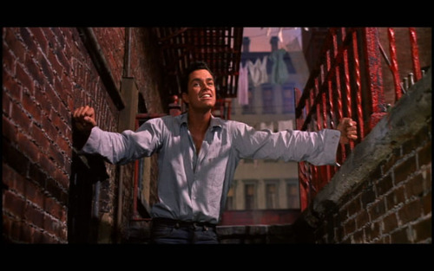

A Brief History of Musicals

What is a musical? __________________________________________________________________________________________________________________________________________________________________________________________________________________________________________
- Increased demand in the late 19th century for popular entertainment suited to ordinary people.
- New theatres opened on Broadway in New York, and the West End in London in response to this demand.
- Variety shows were shown that consisted of a mixture of songs, dances, comedy acts and short sketches.
- Story lines became included to link the items.
- The music became more sophisticated with some composers drawing on the rhythms and harmonies of 20th century classical music and jazz
- Key works in the development of the musical: Show Boat (1927) by J Kern; Porgy and Bess (1935) by G Gershwin; Oklahoma (1943) by R Rogers and O Hammerstein.
- West Side Story (1957) a direct descendent of these 3 works. Plot includes gang violence, ambition, humour and love.
- Musicals today are more popular than ever, but none match the intensity of West Side Story.

Detailed History of Musicals
Vaudeville and burlesque

- The vaudeville was a form of entertainment popular in the 1700s.
- This work comprised popular songs 'borrowed' from other works but with new, often comical and vulgar words set to the music.
- The idea was to shock and entertain the audience.
- The most famous example of this form is The Beggar's Opera by John Gay (1685-1732). The subject matter of this work was a story of thieves and prostitutes!
- Mozart used to attend vaudeville for entertainment with his wife and son and would hear his own operatic music and plots being made fun of on stage.
- This was music for the common people, not for kings and queens.
- The burlesque was similar in form to the vaudeville but tended to be a little more restrained and classical in style. The subject matter was often parody of other serious plays.

Opera-bouffe and operetta

- Opera-bouffe (or comic opera) was popular from about 1870 up until the end of the First World War.
- The music for these works was specially composed as opposed to borrowed from existing works.
- The musical style was light opera and included some spoken dialogue.
- The most famous example of the genre is Orpheus in the underworld (1858) by Jacques Offenbach (1819-1880). This is a comic of the Greek legend of Orpheus and Eurydice.
- However, perhaps more familiar will be the works of a pair of English composers - the lyricist William Gilbert (1836-1911) and the composer Arthur Sullivan (1842-1900), otherwise known as Gilbert and Sullivan.
- Famous works such as HMS Pinafore (1878), Pirates ofPenzance (1879) and the Mikado (1885) combine the humour of the burlesque with a particularly English type of light Classical music that have ensured a lasting popularity England.
- Operetta was literally a 'light' opera.
- The music was full of 19th-century romanticism and nostalgia, often referring to a made-up central European country called Ruritania and involving the misadventures of dukes, duchesses, lords and ladies.
- There is a significant cross-over here with opera-bouffe, with operetta seen as a development of opera-bouffe.
- These forms were very popular in America in the late 1800s as well as its own native forms of extravaganzas, minstrels and melodramas.
- These were all to influence the development of the early 20th-century American musical.

Musical theatre in America
Extravaganzas
These were a form of entertainment of mixed variety similar to the Saturday night variety shows of the 1980s epitomised by the annual Royal Variety Show in London. They included all forms of entertaining from singing to dancing, through to magicians and so on. These were popular in the USA from the 1860s through to 1900.
Minstrelsy
This was a form of entertainment popular in the late 1800s. White people were made to 'black up' to imitate black people in a parody and exaggeration of any character traits. Minstrelsy also poked fun at the rich and powerful. However, with the rise of the civil rights movements and the concept of political correctness, this type of entertainment died away.
Melodramas
These were essentially stage plays that included some musical cues for different
scenes. Dialogue replaced songs but music was used to accompany scenes and add dramatic effects to a situation.
The rise of musical theatre in the 20th century
Broadway musicals
- The rise of the musical in the 20th century was led by America.
- Popular forms of European music were imported into the Broadway musicals of the first half of the century and a host of famous musicals were composed.
- One of the earliest musicals was Showboat (1927) by Jerome Kern, which was a musical play with songs.
- The most successful partnership was between the lyricist Oscar Hammerstein and the composer Richard Rogers.
- These two men established the American dominance of this art form in the first half of the 20th century with works such as Oklahoma (1943), Carousel (1945), South Pacific (1949), The King and I (1951) and the world famous The Sound of Music (1959).
- Other notable works in this period included Annie Get Your Gun (1946) by Irving Berlin, Anything Goes (1934) and Kiss Me, Kate (1948) both by Cole Porter.
- Many of these musicals were later turned into highly successful film versions.
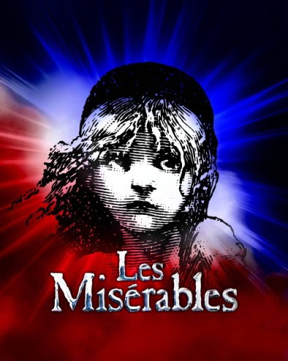
West End musicals
- The famous show Oliver (I960) by Lionel Bart revived the fortunes of the British musical.
- However, it was the partnership of Andrew Lloyd Webber and Tim Rice that changed the face of musical theatre in Britain.
- Their first success was with Joseph and the Amazing Technicolor Dreamcoat (1968), followed by Jesus Christ Superstar (1971) and Evita (1978).
- Lloyd Webber also collaborated with other people to produce a number of other well-known works including Cats (1981), Starlight Express (1984) and Phantom of the Opera (1986).
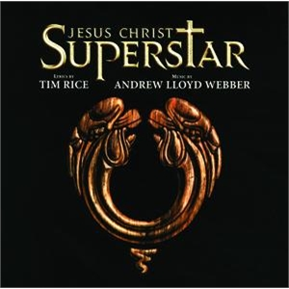
Rock operas
- In addition to the dominance of the Lloyd Webber musicals, there was a whole genre of rock-inspired works.
- In fact Jesus Christ Superstar (1971) was the first in a succession of works.
- Other important rock musicals include Tommy (1969) by The Who, The Rocky Horror Picture Show (1973) by Richard O'Brien, Grease (1978), Little Shop of Horrors (1986) and Rent (1996).
- In more recent times too, there have been musicals that have featured rock songs such as Mamma Mia (1999), now made into a film celebrating the music of Abba, and We Will Rock You (2002), celebrating the music of Queen.

West Side Story

The idea of a musical based on Shakespeare’s play Romeo and Juliet was suggested to Bernstein in 1949 by Jerome Robbins, an American choreographer. The original setting of Verona, a beautiful Italian city in the 16th century was to be transformed into the run-down, violent world of the West Side of Manhattan Island, New York in the 1950s. This appealed to Bernstein as it provided him with the opportunity to write hard hitting music inspired by the jazz and Latin-American rhythms that he had experienced on his holidays.

Romeo and Juliet | West Side Story
Renaissance Italy | 1950s New York
Young lovers who get together despite a running battle between their families | Tony and Maria from rival teenage gangs, the Jets (New York) and the Sharks (Puerto Rico)
Balcony scene | Fire escape of a bleak New York apartment

- West Side Story mirrors much of the Shakespearian play, although now the Capulets and Montagues are transformed to become two opposing street gangs - the 'Jets' and the 'Sharks'.
- The basis of the tension is racially motivated.
- The Jets are white Americans led by Riff and the Sharks are Puerto Ricans led by Bernardo, both protecting their own 'territory'.
- Romeo becomes Tony and Juliet is Maria, who is Bernardo's sister.
- The drama hinges around the love affair of Tony and Maria who meet at a dance at the gymnasium.
- The love affair creates tension as Tony and Maria are from opposing street gangs.
- Even the famous balcony scene in Verona is translated into a fire-escape of a run-down apartment block.
- The set work - 'Something's Coming' - appears near the beginning of the story, and sees Tony looking expectantly towards a new life away from the gang.
- He wants to leave the Jets, but as the first song says 'once you're a Jet you're a Jet until your last dying day’.
- He has found a job working at Doc's drug store and the future looks promising.
- However Riff, the leader of the Jets, is determined to challenge Bernardo to a fight that night at the dance.
- He calls on Tony just before he sings the song 'Something's Coming' to persuade him to help in the planned 'rumble' (fight).
- Tony agrees but insists on no future part with the gang.
- However, the drama is set in motion and from this point onwards the tragedy of the storyline inevitably unfolds.
The music of West Side Story was cutting edge when compared to musical theatre
pieces up to this time. The new elements in this work were:
- Dark theme rooted in violence and tragedy
- Use of long, extended dance scenes to convey the drama
  - Bernstein's marriage to Chilean Fellicia Monteleagre introduced him to the Latin American dance rhythms that were to be used in much of the music in this work.
  - There is a whole sequence of dances used in the gymnasium scene, including the mambo and cha-cha.
- Sophisticated synthesis of jazz and classical musical idioms
- Focus on social problems and tensions of contemporary America.
- Music used ideas from opera, music hall and Latin American dances.

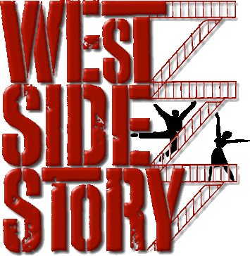
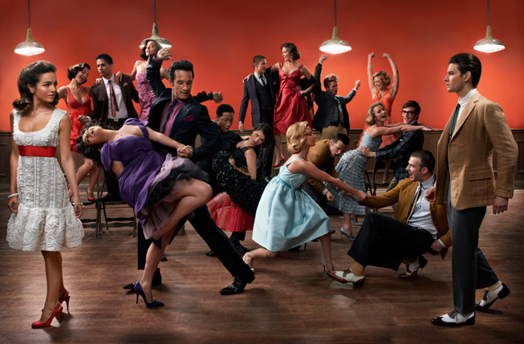
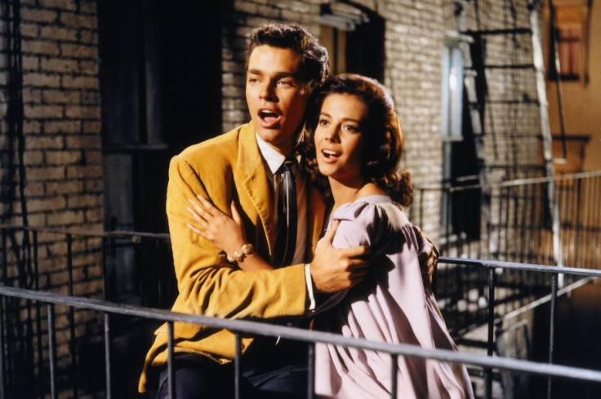
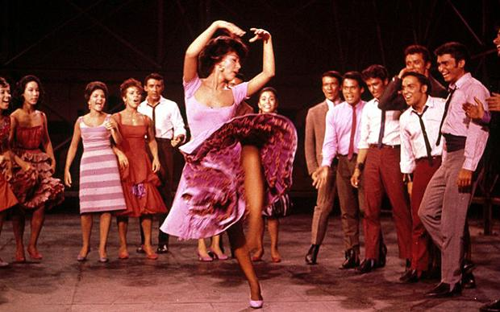
‘Something’s Coming’ (1957)
Tony, who was once the leader of the Jets, sings the song ‘Something’s Coming’ it is his first solo, and in it he expresses his hopes for a better future, it establishes his optimistic character. The music in this song reflects this desire for a better future than the gang culture. How does the music do this?
________________________________________________________________________________________________________________________________________________________________________________________________________________________________________________________________________________________________________________________________________________________________________________________________________________________________________________________________________________________________________________
Unfortunately though his relationship with Maria, sister of the rival gang leader, is ultimately doomed; it is a love story of betrayal and violence leading to Tony’s death.
Features and Key Musical Elements in the Song
- Used Ideas from Opera, Music Hall and Latin and American Dances/ rhythms
- Jazz and Classical Music idioms
- Mambo and Cha cha are used
- Jazz based harmony – adding Blue notes and other dissonances
- Syncopated rhythms infused the music, including ‘Push’ rhythm anticipating the beat
- The motif – the interval of a Tritone – e.g. G sharp to D. this interval is known as the devil in Music, representing sinister and evil moods
- Huge use of short riffs
- Cross Rhythms
- Layered textures of separate parts
- A combination of short and snappy phrases and long sustained notes.

INSTRUMENTATION

‘Something’s Coming’ is written for solo tenor accompanied by a pit orchestra/band. The orchestra is huge – 31 piece including woodwind, brass, string, percussion, guitar and piano!
Notice that the Tenor part is printed in the treble clef but sounds an octave lower then written. The pit orchestra is usually positioned in front of the stage and therefore limits the number of players that can be used.
West Side Story was originally written to be performed without amplifying the voices. Write down two ways in which Bernstein ensures that the band doesn’t overpower the singer in ‘Something’s Coming’:
__________________________________________________________________________________________________________________________________________________________________________________________________________________________________________________________________________________________________________________________________________________________________________________

Bernstein uses a variety of instrumental techniques within this piece to help enhance key words. Look out for example the harmonics and tremolo played by the strings in the words ‘The air is humming’.
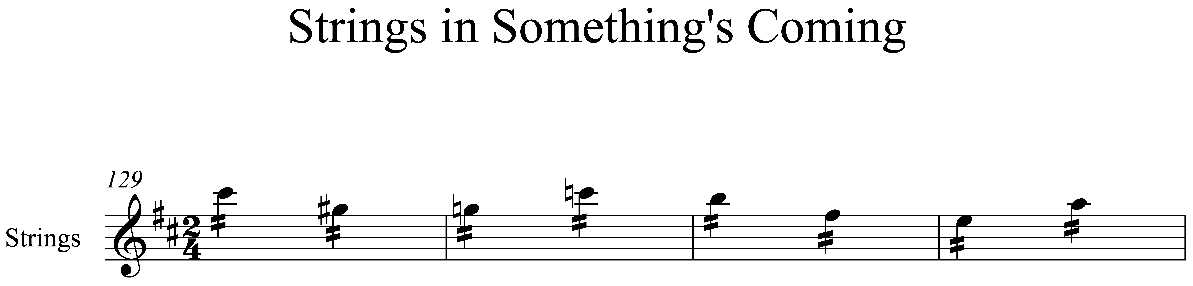

STRUCTURE AND MELODY

It does not follow a conventional verse – chorus structure, but has several Musical ideas and sections that recur.

Part of song | Length
Introduction | Bars 1-3 (3 is repeated ad lib)
Section A | Bars 4-39
Section B | Bars 40-105
Section B1 | Bars 106-140 (shortened version of B)
Section A1 | Bars 141-157 (shortened version of A)
Outro | Bar 158 is a slow fade out

TEXTURE

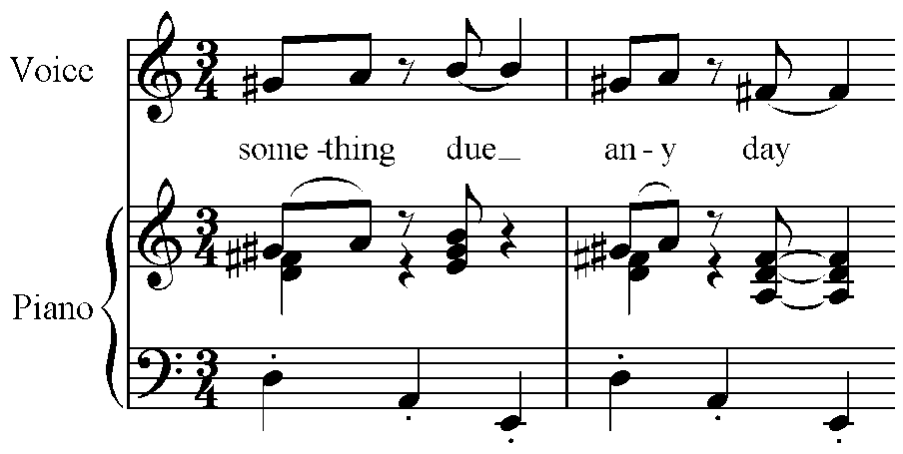
The texture is melody over accompaniment (homophonic) throughout. He does however vary the accompaniment and has three main ideas:
- A repeating riff in the bass:
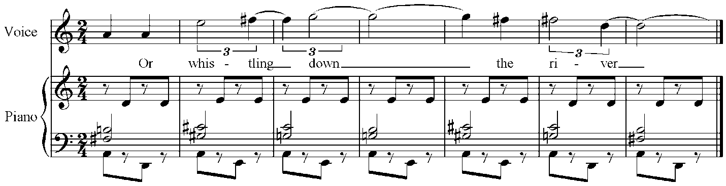
- Short, syncopated chords in bars 21-26
- A fast, um-cha accompaniment in bars 32-140

RHYTHM, METRE AND TEMPO

To help create the feeling of anticipation and excitement Bernstein uses changes in metre, fast tempo and syncopated rhythms – notice also the use of the “push” rhythm which anticipates the beat:

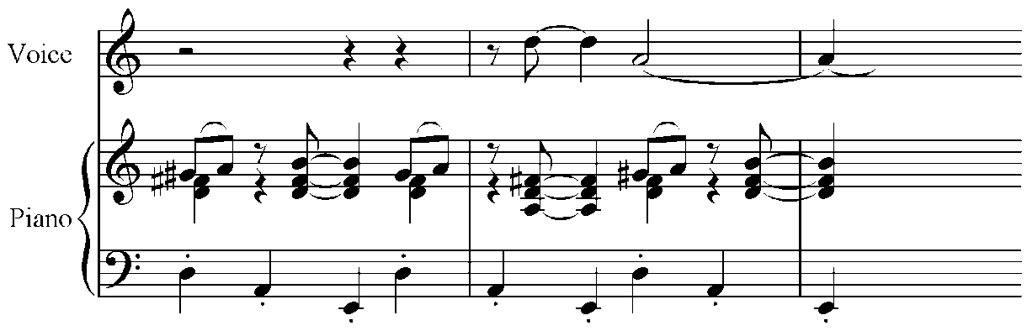

He also uses cross rhythms: two conflicting rhythms that cross the pattern of accented and unaccented beats. Here are two examples within ‘Something’s Coming’.
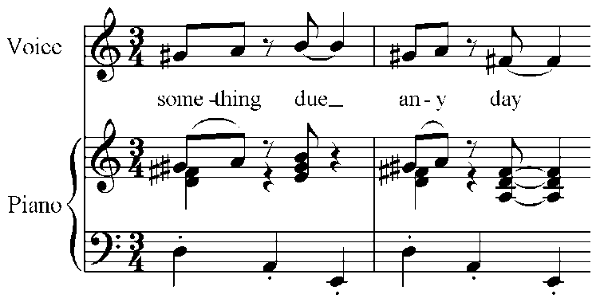

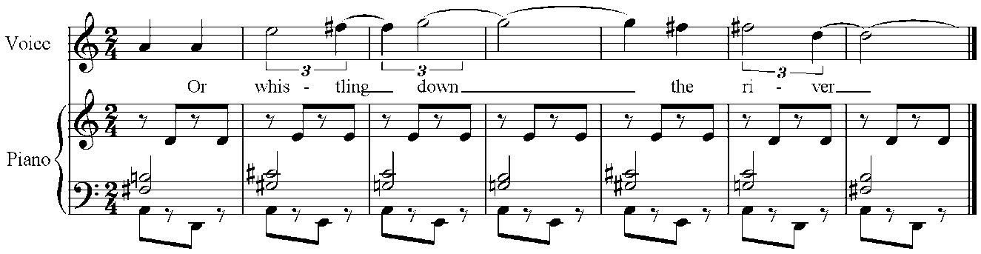

HARMONY AND TONALITY

What is the key of this piece? ________________________________________________

Does it modulate?_________________________

If so where and to which key? ______________________________________________________________
______________________________________________________________
______________________________________________________________

We discussed earlier how Bernstein was influenced by Jazz and Latin-American music. The jazz influences become very clear particularly within the harmonies where there is frequent use of 7th chords – these are known as ‘blue’ notes. He also uses the interval of a sharpened fourth that creates a tritone. Look at the example below:
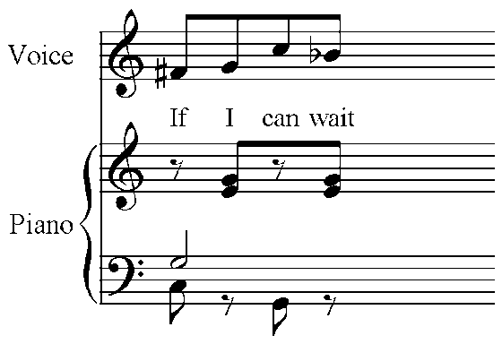
Flattened Seventh
Tritone

What is a tritone and where else can you see one?
__________________________________________________________________________________________________________________________________________________________________________________________

What harmonic device does Bernstein use in the last bar to create the feeling that the piece hasn’t finished?

Choose from:

Syncopation Pedal note Flattened seventh Cross rhythm

Which two options are the odd ones out and why? ______________________________________________________________
____________________________________________________________________________________________________________________________

H/W - West Side Story contains several types of songs other than the solo song. Listed below are a variety of songs found in this musical which include chorus numbers, duets and a quintet:

‘One Hand, One Heart’ ‘Jet Song’ ‘Tonight’ ‘America’ ‘A Boy Like That’
Which one of the songs above is a quintet? ______________________________________________________________

Two of the songs are duets, name one of them: ______________________________________________________________

The final two songs are chorus numbers, what does this mean?
____________________________________________________________________________________________________________________________

AoS 2
Bernstein: West Side Story – ‘Something’s Coming’

Terms | Definitions
Choreography
Production
Intervals
Syllabic
Tritone
7th Chords
Riff
Harmonics
Push rhythm
Tremolo
Syncopation
Cross rhythm
Flattened seventh

